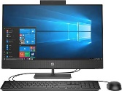 | Significant Individuals in Medicine- Florence Nightingale and Mary Seacole |  |  |  | 
 | Year Group: 2 | Subject Focus: History | Term: Spring 2
Key facts  - Florence Nightingale was born in 1820 in a big city in Italy called Florence. That is how she got her name.  - She became known as the ‘Lady with the Lamp’.  - Florence Nightingale is remembered for showing people that nursing is a very important job.  - In the 1800s there was no medicine to stop infections killing people!  - Mary Seacole was British-Jamaican, born in 1805.  - Mary grew up in her mother’s hotel in Jamacia. Mary had lots of experience caring for sick British soldiers.  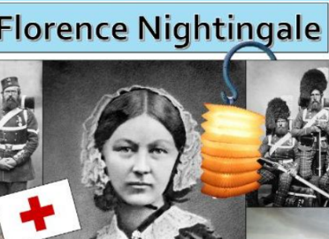  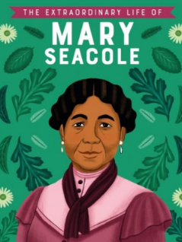  - She used her medical knowledge and looked after wounded soldiers from the battlefield. |  | Parents as partners:  - The Thackery Medical Museum has lots of interesting exhibits regarding medicine in the past.  Exciting books/ web links:  Who was Florence Nightingale? - BBC Bitesize  Who was Mary Seacole? - BBC Bitesize  Florence Nightingale facts for kids | National Geographic Kids (natgeokids.com)  Mary Seacole Facts for Kids | National Geographic Kids (natgeokids.com)  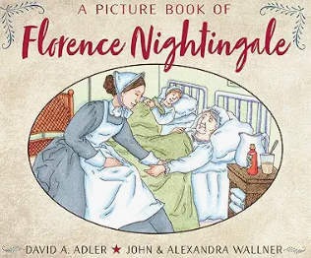  A picture book of Florence Nightingale  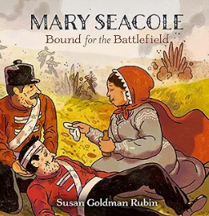  Mary Seacole: Bound for the Battlefield | Key words:  - Could your child design and draw a fact-file all about Mary Seacole or Florence Nightingale?
  achievement | a thing done successfully with effort, skill, or courage
  chronology | the arrangement of events in the order they happened
  Crimea | Located on the peninsula of Ukraine lying between the Sea of Azov and the Black Sea.
  era | a long and distinct period of history
  famous | known about by many people
  first hand | directly experienced by somebody
  impact | the result an action has.
  medicine | What makes people better- often liquids or tablet form.
  society | the community of people living together.
  soldiers | people who fight in battles or wars.
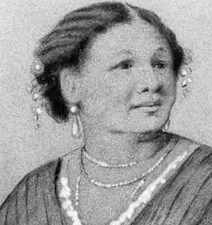
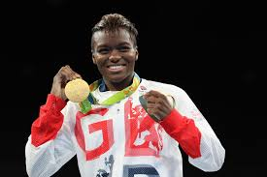
Key people/ places

Mary Seacole

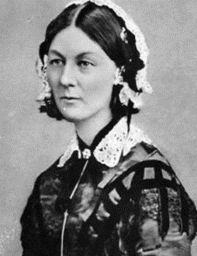

Florence Nightingale

Crimea- This was where the Crimean War took place. Mary Seacole and Florence Nightingale both looked after the wounded soldiers.

 |  | We Are Learning To:  - Know who Florence Nightingale was and why she is famous.  - Know who Mary Seacole was and why she is famous.  - Compare the achievements of Mary Seacole and Florence Nightingale.  - Understand the impact Mary Seacole and Florence Nightingale had on today’s society. |  | Themes  

