 | DT: Textiles – Moving Monsters
 | Year Group: 2 | Subject Focus: DT | Term: Spring 2
Key facts:  Everyday objects can be made to move.  Mechanisms create moving objects.  Mechanisms can be found in everyday objects.  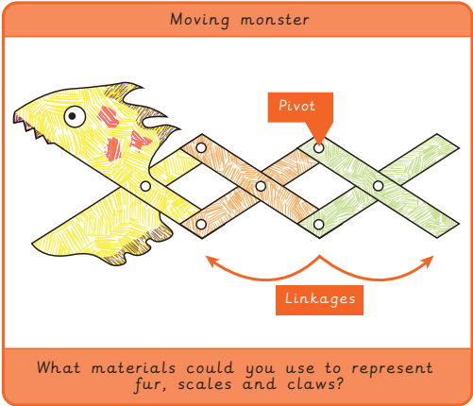 |  |   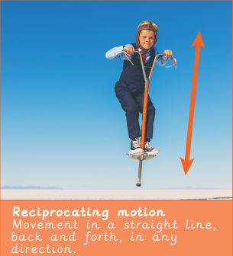  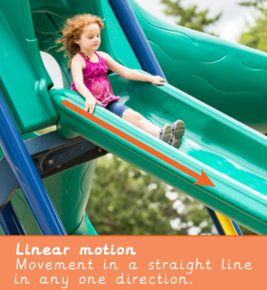  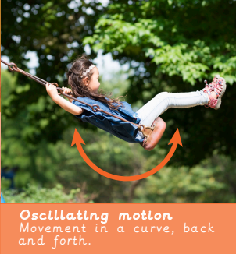  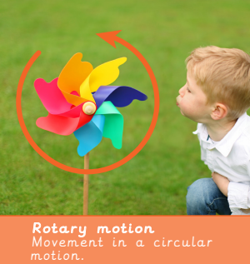 | Key words:  .  Real life: End results!  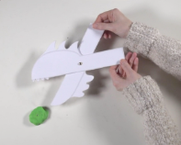
  criteria | A set of rules to help designers focus their ideas.
  evaluation | When you look at the good and bad points of something and see how you can improve it.
  input | The energy that is used to start something moving.
  linkage | Lengths of material that are joined together by pivots, so the links can move as part of a mechanism.
  mechanical | Something that can move because several pieces work together like a machine.
  mechanism | A collection of parts that work together to create a movement, eg. bicycle
  moving | Changing position.
  output | Output is the motion that happens as a result of starting the input.
  pivot | The central point, pin or shaft on which a mechanism turns or swings.
  wheel | A circular object that turns round.

