
Year 2 Spring 2 Newsletter
We would like to welcome everyone back after the break.
Year 2 continue to work hard and continue to develop our skills and knowledge.
In Maths, we will be learning multiplication and division – including times tables.
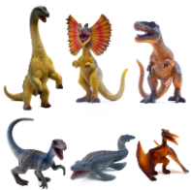
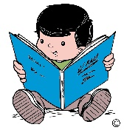
In English we are looking the book ‘Harry and the Bucketful of Dinosaurs’. We are going to learn how to write a character description by using adjectives and noun phrases. We will also be shortly celebrating World Book Day.
In Science our unit of study is ‘Plants’. We will be observing and describing how seeds and bulbs develop into plants.
In Music we will continue to work on composing our own tunes. PSHE sees us continuing to look at families and relationships. In RE we will continue to look at important books and stories.
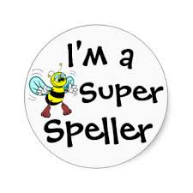
In DT we will be creating a moving monster while Computing sees us creating pictures.

We will continue to work with our coaches in PE. We would like to remind you again that our PE days are Tuesday and Friday, and your children should wear the correct PE kit, including pumps, on these days. We would also request that, in line with school policy, any earrings are removed on these days.
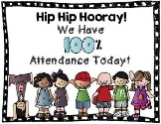
The children will continue to bring home spellings each week, usually on a Friday, that they will need to learn for a test the following Friday. We always appreciate your support with helping your child learn their spellings.
Reading is very important. Children need to read regularly to improve their fluency and understanding, and we would like to see all Year 2 children reading at home.
Your child’s attendance, as always, is very important. Children find it very difficult to keep up with their work, if their attendance is not consistent.
We would like to thank you for your continued support.
Mrs. Austin and Miss Lennon

