Year 4 Newsletter (Spring 2)

Welcome back to Year 4 - Fine class! I hope you had a lovely half term. As we embark on second half of the term, get ready for a wealth of learning experiences and engaging projects.
Our learning journey
Our Geography unit for this half term will be exploring volcanoes.  We will develop our understanding of how volcanoes are formed and where the world’s volcanoes are found. We will also explore the positives and negatives of living near a volcanic area as well as enhancing our fieldwork skills.   | In Science, we will we will continue to focus on sound.    We will learn how vibrations cause sounds and how sounds travel through different mediums at different speeds. The children will discover how sounds can change in pitch and loudness and be able to explain this using scientific language. | In our Maths lessons, we will focus on fractions, understanding mixed numbers and being able to compare and convert these to improper fractions. We will also explore the basics of adding and subtracting fractions. We will then finish the half term learning about decimals, dividing numbers by ten and a hundred.  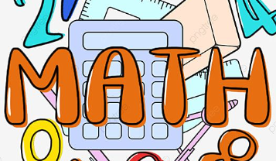 | In English, we will then read Escape from Pompeii and write a story imitating the tragic events, using powerful vocabulary to enhance our description.  Finally, we will write an information text about volcanoes, showcasing our geography learning. Children will continue to work on constructing accurate sentences as well as focusing on improving their handwriting and spelling.  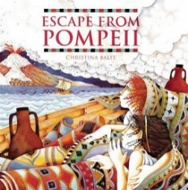

Diary Dates:  PE will take place on a Monday and Tuesday. Children should come to school wearing their PE kits on these days. PE Kits should consist of black, navy or grey tracksuits or shorts (no logos) and a t-shirt in their house colour.  On Monday 2nd March, we will launch World Book Week with a pyjama day.  On Tuesday and Wednesday 10th and 11th March, it is parents evening.  On Thursday 12th March, it is school photo day.  On Friday 27th March, it is Open Doors at 2:15. | Class routines:  - The children are expected to read at home every night. Reading records and books should be brought to school every day so that a member of staff can read with them in school. These reading books will be changed on a Friday if the reading record has been signed.  - Each Friday, the children will complete a spelling quiz. The spellings focus will be sent home on a Friday, ready to learn for the following Friday. The children will need to practise these at home (and at school) on a regular basis.  - Pupils should continue to log onto TTRockstars to improve their times tables knowledge. This is constantly monitored as well as accessed in class to prepare the children for their Multiplication Times Table Check in June.
Finally, please remember to log onto the class page on the school website to keep up to date with our latest news: https://www.crossgatesprimary.co.uk/class-pages/ or by accessing the school twitter page.
Mrs Coombes and Mrs Middleton

