 | DT: Structure - Pavilions
 | Year Group: 4 | Subject Focus: DT | Term: Spring 2
Key Knowledge:  - To understand what a frame structure is.  - To know that a ‘free-standing’ structure is one that can stand on its own.  - To know that a pavilion is a decorative building or structure for leisure activities.  - To know that cladding can be applied to structures for different effects.  - To know that aesthetics are how a product looks.  If you love DT, you could be:  - Engineer  - Product designer  - Fashion designer  - Robotic engineer  - Video game designer     |  | 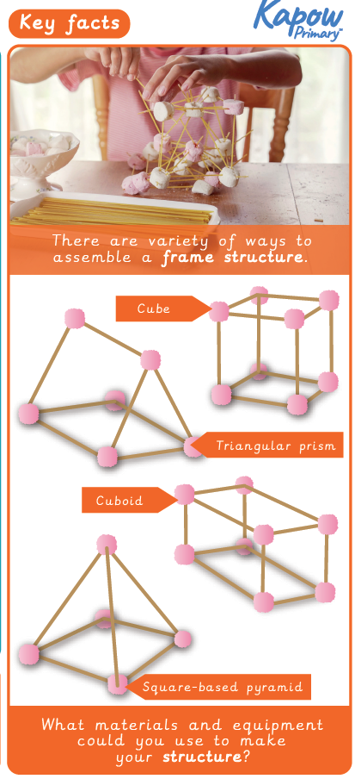 | Key words:  Real life:  These are some real pavilion structures.  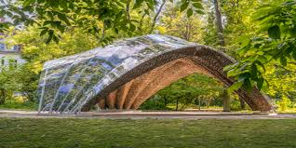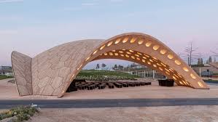
  Aesthetic | how an object looks
  Cladding | a material put on top of a structure to protect it
  Frame Structure | building the inside of the structure first
  Design Criteria | to make, draw or plan for something
  Inspiration | to gain ideas from different sources
  Pavilion | a decorative building or structure
  Reinforce | to make a structure stronger
  Stable | an object that doesn’t topple over easily
  Texture | the way that something feels (soft, rough)
  Structure | something that has been made and put together and can usually stand on its own
?

