 | Famous Explorers |  |  | 
 | Year Group: 1 | Subject Focus: History | Term: Spring 2
Key Facts –  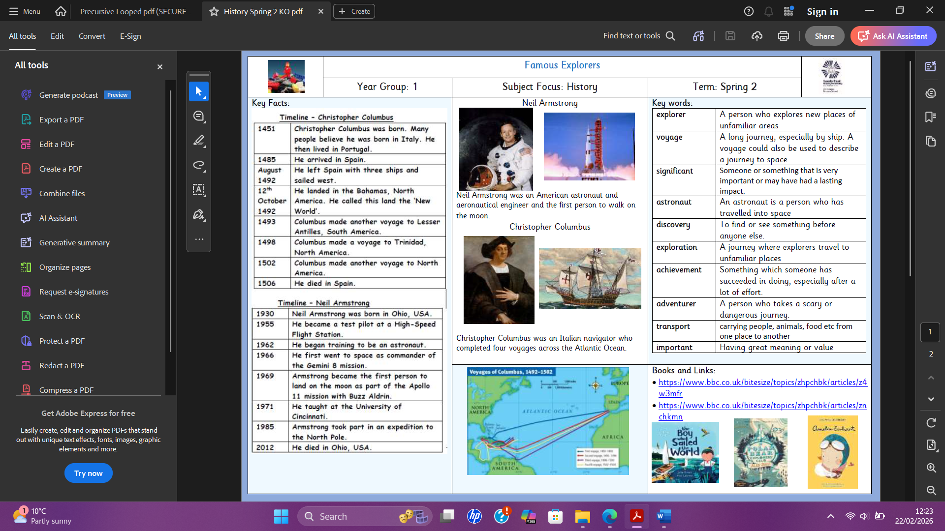 |  | 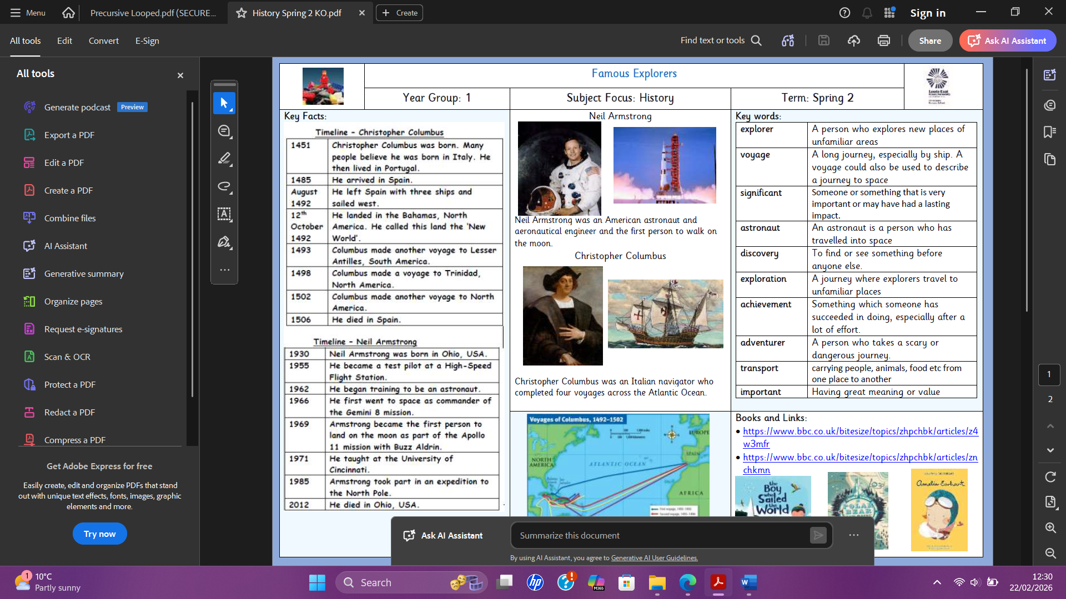  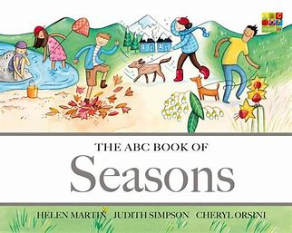  Exciting books and websites –  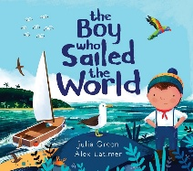  Who was Christopher Columbus? - BBC Bitesize  Who was Neil Armstrong? - BBC Bitesize | Key words:  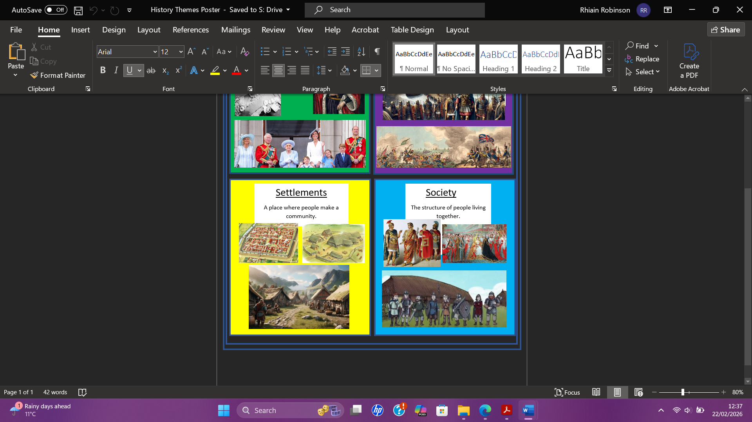  We will be looking at the theme of society in this topic.
  explorer | A person who explores unfamiliar areas.
  astronaut | An astronaut is a person who has travelled into space.
  important | Having great meaning or value.
  exploration | A journey where explorers travel to unfamiliar places.
  discovery | To find or see something before anyone else.
  achievement | Something which someone has succeeded in doing, especially after a lot of effort.
  voyage | A long journey, especially by ship. A voyage could also be used to describe a journey into space.
  significant | Someone or something that is very important or may have had a lasting effect.
  transport | Carrying people, food or animals etc from one place to another.
  adventurer | A person who takes a scary or dangerous journey.

