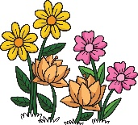 | Plants |  |  | 
 | Year Group: 1 | Subject Focus: Science | Term: Spring 2
We are learning to:  - Know the different between evergreen and deciduous trees.  - Know that there are different types of plants.  - Identify and classify leaves.  - Know that plants can grow.  - Identify and name a variety of plants.  - Identify and name the structure of plants.  - Identify and name a variety of evergreen and deciduous trees.  Some plants and trees you can begin to recognise - |  | 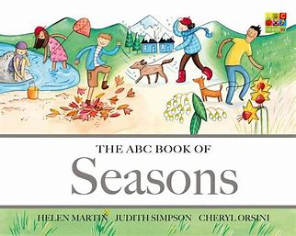  Exciting books and websites –  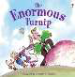  Roots, Stem, Leaves, Flower | Parts of a Plant Song | Parts of a Flower Song  Plants - KS1 Science - BBC Bitesize  Wild and garden plants – KS1 Science curriculum - BBC Bitesize | Key words:  Parents as partners:  - Visit local outdoor areas and observe the seasonal changes. Which plants or trees can you spot?  - Plant a bulb or seed. Observe it change over time.
  Plant | A living thing that grows in water or the Earth
  Tree | A woody plant with a trunk.
  Flower | The part of a flower which blossoms. They attract insets or birds.
  Fruit | Something which grows on a tree or a bush and which contains seeds or a stone covered by a substance that you can eat.
  Evergreen | The type of tree that keeps their leaves all year round.
  Deciduous | They lose their leaves during the winter months.
  Bud | Growth at the tip or on the side of a plant stem that later develops into a flower, or a leaf or new shoot.
  Leaf | A leaf is a part of a plant that’s usually green and attached to it by a stem or a stalk.
  Stem | The main stalk of a plant.
  Root | It is typically found underground and it absorbs water and nutrients for the plant.

