 | DT: Structures (creating a windmill)
 | Year Group: 1 | Subject Focus: DT | Term: Spring 2
Key facts:  - Windmills can be used to grind grain into flour, to pump water or to produce electricity.  - There are nearly 10,000 wind mills in the UK alone!  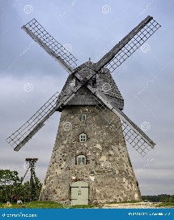  We Are Learning To:  - Design stable windmills that can stand on their own and catch the wind.  - Evaluate our designs and discuss how we can improve them for next time.  - Develop our problem-solving skills and understand how a design can serve a purpose. |  | Technical Knowledge:  A wind mill has an axle, similar to ones that cars use that help connect the sails and enable them to spin around with the wind.  Windmills need to have a rotor, which will help the sails to spin around.  Windmills need to have a strong structure to help the sails stay strong and not topple over.  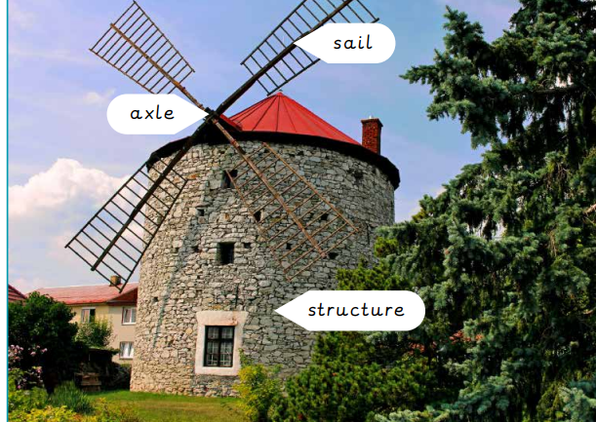  What will your windmill look like? | Key words:  .  Real life:  - Daniel Halliday made the first windmill in 1854.  - Daniel was an inventor, machinist and businessman.  - Daniel was the first person to make a windmill move to face the direction of the wind.  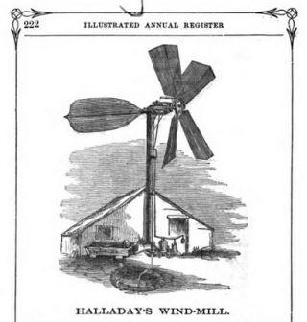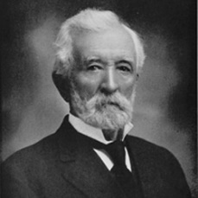
  Axle | A long straight piece of material that connects to a rotating part
  Evaluation | Looking at what is good and bad about something and thinking how to make it better
  Sail | The part that moves in the wind
  Stable | An object that does not topple over easily
  Test | To find out whether something works as it should
  Structure | Something that is built for a purpose
  Windmill | A structure with sails that moves by the wind
  Design | A plan to show the look and workings of a building
  Rotor Blades | The long air foil that rotates
  Rotor | The rotating part of an electric machine, such as a generator.

