Welcome back Year One! I hope you all had a lovely week off. You all blew me away last half term with how independent you are all becoming and your work has been incredible so I can’t wait to see how you all progress even more! We have lots of amazing things planned in the next few weeks, a trip to Harlow Carr, Science week and World book day.
Maths | English | History | Science
In Maths, we will be learning about mass and volume. We will be comparing volume, learning about what is heavier or lighter and will understand how to measure capacity. We will also start to learn to count in 2’s and 5’s and will continue our work on the ten times table.  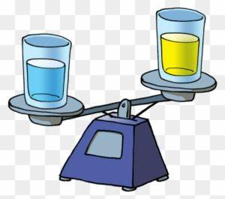 | In our writing lessons, we will be retelling the story of Jack and the Beanstalk. We will be expanding our sentences with conjunctions and perfecting our precursive handwriting! We will also be exploring and writing our own riddles. | In History we will be learning about the lives of famous explorers such as Neil Armstrong and Christopher Columbus. We will find out why they are so significant and will learn the timeline of their lives.   | In Science we will be learning about plants and flowers. We will study how flowers drink up water and what they need in order to grow and survive. This will be furthered by our trip to Harlow Carr. We will also be dissecting flowers and investigating the different parts of them to see why they are all so important!

Important Information –  - Year One will have PE on a Wednesday and Thursday afternoon. Please ensure they have their PE kit with them on these days.  - Please continue to work with your child practising their phonics. The screening test is in June and any extra work will be greatly beneficial to your child. Any questions about this or if you would like some practise phonics materials, please come talk to me. | Things to know –  - Each Friday, the children will complete a spelling test. Spellings will be sent home on a Friday and should be practised at home.  - Reading records and books should be brought in to school on a Thursday. Please ensure you are reading at home with them too.  - New library and reading books will be sent home on a Friday for the children to read over the weekend.  - Year One have a trip to Harlow Carr on the 18th March. Please ensure your child has sensible clothes and shoes as it may be raining and we will be doing lots of walking.

Keep up to date with your child’s learning by going on to the school website and see what they have been doing. Year 1 | Cross Gates Primary School .Any questions about your child or their learning, please feel free to come to me to arrange a time to meet.

