




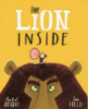
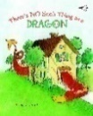

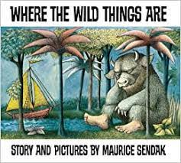


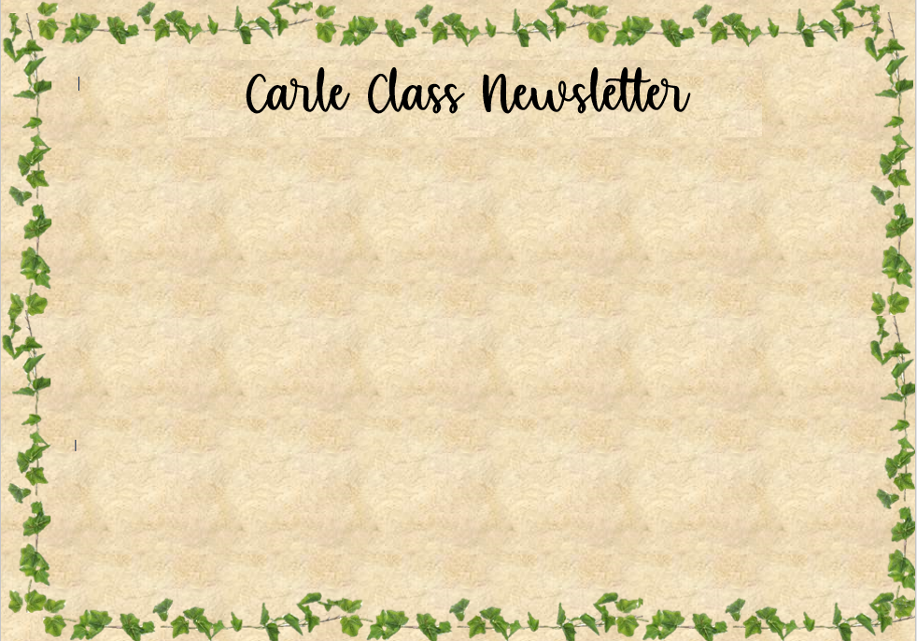
Welcome back and Happy New Year!
We hope that you had a wonderful, relaxing Christmas and New Year period with your families and that the children are recharged ready for the start of a new half term.
Tapestry is a great platform to share and celebrate the achievements of your child. We encourage you to upload your own photos and videos. The children are always very excited for us to see their photos from home. We would love you to share some photos from the Christmas period so that the children can revisit and talk about their experiences. Thank you in advance for your support!
This half term, we will have some new children joining us in Nursery for our January intake. You may hear your children talking about some new friends, and the Nursery cloakroom and classroom may feel a little bit busier and noisier than usual as we help our younger children to settle. Thank you for your patience during this transition period.
Miss MacNay and Miss Jessop

Reminders
- If your child is due to start school in September 2025, you can apply online until 15th January. If you need any help with your application, please speak to Miss Harrison urgently.
- Spending time in the outdoors is a huge part of our curriculum offer in Early Years and so we continue to spend a lot of time learning outside, even in colder weather. We risk assess our outdoor area daily to ensure it is safe for children to play. Please ensure your child is dressed appropriately for play in the outdoors – a warm coat, hat, gloves, wellies and an all-in-one puddle suit (we do have spares of these in school if needed). All children should also have a bag with 2 sets of spare clothes in school at all times.
- We continue to update our class page on the school website. Please check our page each week to share in our achievements, see what we have been learning about in school and find out ways that you can support learning at home!
https://www.crossgatesprimary.co.uk/nursery-5/

Reading Cafe and Stay and Play
We would like to continue to invite you to our Reading Cafés.
The first session will be on Thursday 22nd January 2:45-3:00 pm and the second on Tuesday 27th January at 2.45pm -3.00pm.
It has been wonderful to welcome so many families- thank you for your continued support.
Our next Stay and Play session will be on Wednesday 11^{h} February at 2:00pm.
We look forward to you joining us at these events!

Favourite 5 and Virtual Library!
Each half term, we will be reading 5 key texts – This half term, our ‘Favourite 5’ books are:

Where the Wild Things Are
The Gruffalo’s Child
The Lion Inside
Love Grows Everywhere
There’s No Such Thing as a Dragon

You can listen to Miss MacNay and Miss Jessop read these stories in our virtual library.

