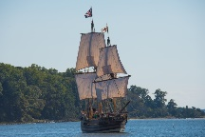 | Continents and Oceans |  |  | 
 | Year Group: 2 | Subject Focus: Geography | Term: Spring 1
Key facts  - Leeds is a city in the country of England.  - England is in the United Kingdom  - The United Kingdom is in the continent of Europe along with countries like Spain, France and Greece.  - There are seven continents:  - Europe  - Asia  - Africa  - North America  - South America  - Antarctica  - Australia (also known as Australasia and Oceania)  - There are five oceans:  - Pacific Ocean  - Atlantic Ocean  - Indian Ocean  - Southern Ocean  - Arctic Ocean  - The further away from the Equator you travel, the colder it gets. Some continents have very hot weather and some have very cold weather.  - Sailors used a compass to find their way across the oceans. We use the words North, South, East and West to describe the direction we are travelling in. |  | Parents as partners:  - Go to the library and look at atlases. Do you remember our learning about hot and cold places in Year 1? Perhaps you can find those countries? Do you remember where the hottest and coldest parts of the world are?  - Discuss how you would travel to different places like Temple Newsam, Leeds City Centre, York, London, Spain, Antarctica?  - Where would you go if you could go anywhere in the world? Can you draw a picture of what you think it might be like?  - Draw and write a postcard of your favourite place that you have ever travelled (no matter how near or far).  - Could you make a model of a pirate ship? Don’t forget it needs to float!  Exciting books/ web links:  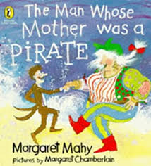  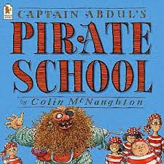  https://www.bbc.co.uk/teach/class-clips-video/geography-ks1--ks2-the-world/zkk6t39  https://www.bbc.co.uk/bitesize/topics/zvsd8xs/articles/z6vyf4j  https://www.bbc.co.uk/bitesize/subjects/zcdqxnb  https://www.youtube.com/watch?v=K6DSMZ8b3LE&vl=en | Key words:
  atlas | A book of maps, tables and charts.
  coast | The land next to the ocean.
  compass point | Any of the main points of a compass: North, South, East and West.
  continent | A very large area of land that consists of many countries. Europe is a continent.
  country | An area of land that is controlled by its own government.
  equator | The imaginary circle around the earth that is halfway between the North and South Poles.
  harbour | A sheltered area of water where boats can be anchored.
  island | A piece of land that is completely surrounded by water.
  ocean | One of the five very large areas of salt water on the Earth’s surface.
  sea | The area of water around land.

Key people/ places
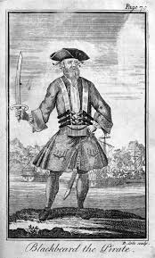
Black beard was an English
pirate who travelled by boat to
the West Indies and North
America.


