 | Living things and their habitats |  |  | 
 | Year Group: 2 | Subject Focus: Science | Term: Spring 1
Key facts  - Living things can be divided into two main groups: plants and animals.  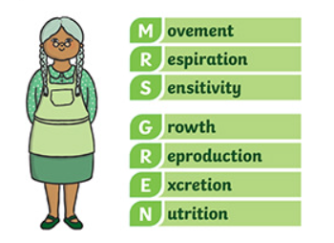  - Habitats are where something lives- these have to be suitable for the animal or human.  - MRS GREN- the seven life processes are: |  | Our Learning Journey:  We Are Learning To…  identify and name a variety of plants and animals in their habitats, including micro habitats.  explore and compare the differences between things that are living, dead and things that have never been alive.  identify that most living things live in habitats to which they are suited and describe how different habitats provide for the basic needs of different kinds of animals and plants and how they depend on each other.  Our five enquiry types:  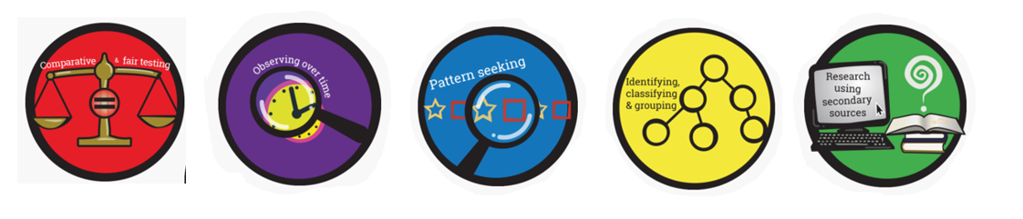  Working Scientifically Skills:  In this unit we will be:    Asking Questions    Making Predictions    Observing    Interpreting and Communicating Results    Evaluating | Key words:
  adapt | The adjustment of organisms to match their environment to survive.
  dead | No longer alive. For example, the dead tree was grey and leafless.
  environment | Everything around us, including living and non-living.
  food chain | A series of living beings in which each serves as food for the next.
  habitat | The environment where plants and animals live.
  living | To be alive and breathing.
  micro-habitat | A very small place within a larger habitat where tiny living things, like minibeasts, find food, water, and shelter, such as under a log, inside a pile of leaves, or under a stone, providing them with safety and specific conditions like moisture and shade.
  never been alive | To have never had life or have been living.
  suitable | Right for the situation or purpose. For example, “I wanted to buy him a suitable going away gift”.
  survive | To remain alive.
Key people

Steve Irwin – Australian wildlife expert.
Robert Winston – British human scientist.
Exciting books/ web links:
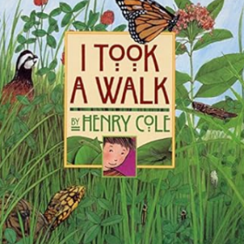
‘I Took a Walk’ by Henry Cole.
This is a beautifully illustrated introduction to British wildlife and habitats.

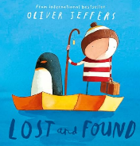
‘Lost and Found’ by Oliver Jeffers.

Make a bug hotel! https://www.bbc.co.uk/cbbc/thingstodo/bp-bug-mansion-make

Take the quiz…
https://www.bbc.co.uk/bitesize/articles/zs73r82
Parents as partners:
My Habitat - Living, Dead, or Never Alive: Can your child choose and sort objects from their homes and gardens into categories depending on whether they are living, dead or have never been alive?
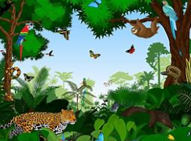
Garden Food Chain: can your child make up their own food chain from living things that can be found in their garden or a nearby park?

