 | Art: Craft and Design
 | Year Group: 2 | Subject Focus: Art | Term: Spring 1
Skills:  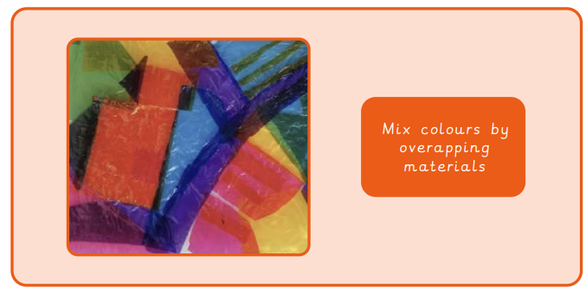  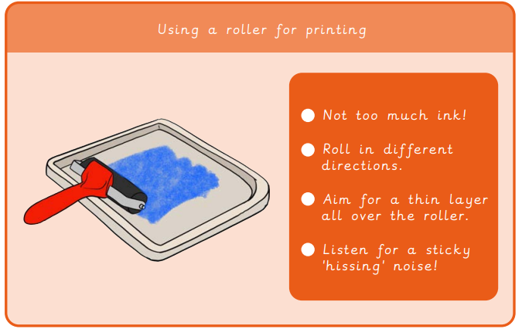  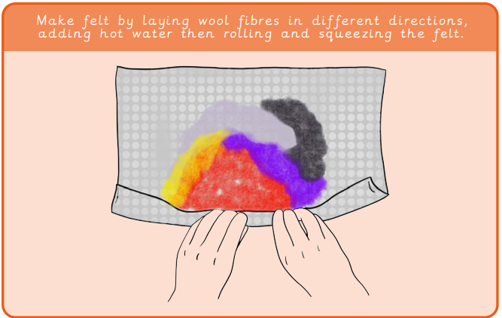 |  | Famous Artwork:  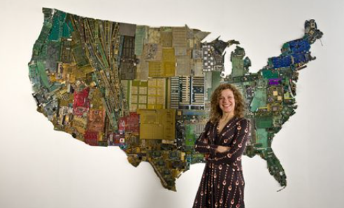  Susan Stockwell  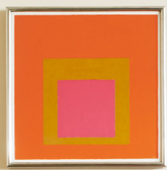  Josef Albers  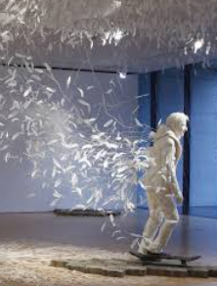  Kim Soon Im | Key words:  About the artists:  Susan Stockwell  - Born in Manchester in 1962.  - Makes sculptures, collages and drawings.  Josef Albers  - American-German artist born in 1888.  - Famous for his painting of squares.
  abstract | Where the subject doesn’t look like it does in real life.
  composition | Putting different elements together in a pleasing way.
  curator | Someone who organises and looks after collections in a museum.
  felt | A material made by squashing fibres together.
  fibre | Threads of wool.
  light | Brighter and bolder.
  negative print | Ink that shows the background rather than the picture.
  pattern | A design in which shapes, colours or lines are repeated.
  stained glass | Colourful decorative glass that makes a design.
  texture | The surface of a piece of art.

