
Year 2 Autumn 1 Newsletter
Welcome to Year 2. We are looking forward to a very exciting half term, especially getting to know the children.
The Year 2 class teacher is Mrs Austin and our Teaching Assistant is Miss Lennon.
Here is a brief summary of what we will be doing during this half term;
In Maths, we are going to be working on our understanding of Place Value along with practicing addition and subtraction strategies.
In English, we are going to start by writing a poem and then we will be developing our sentence writing skills. Children will be exposed to a variety of texts that will help to develop their vocabulary.
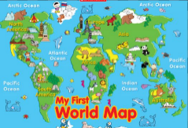
Our Science unit is called ‘Animals including Humans’ and is all about how we keep healthy. This also links to our PSHE unit where we will learn about health and wellbeing.
Our study unit for Geography is all about working with maps.
RE will see us looking at different community festivals and celebrations, whereas in Art we will be telling a story through drawing.
Our PE days are Tuesday and Friday, and your child will need a fully named PE kit in school on those days. We would also request that, in line with school policy, any earrings are removed on these days.
We would like your child to bring their reading books to school every day, so that we are able to read with your child regularly. We always appreciate your support with helping your child with their reading at home.
Attendance, as with any year group, is very important. If your child misses a day, this has a negative impact on their education. Obviously if your child is unwell, you must inform school of their absence.
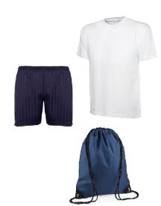
If you would like to know anything regarding your child in Year 2, please do not hesitate to contact us. We would like to thank you for your support.
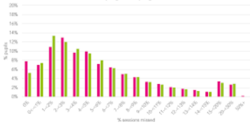
Mrs Austin and Miss Lennon

