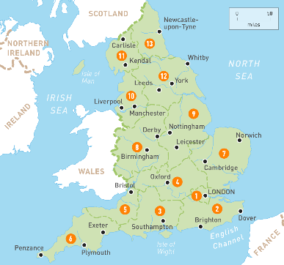
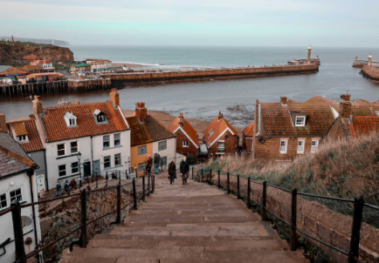

https://www.google.com/url?sa=i&url=https%3A%2F%2Fwww.etsy.com%2Fuk%2Flisting%2F1477679581%2Fsummer-png-transparent-non-transparent&psig=AOvVaw2fl3BkaGXQlJgCJKfQLgXZ&ust=1748794312520000&source=images&cd=vfe&opi=89978449&ved=0CBQQjRxqFwoTCKCritCMzo0DFQAAAAAdAAAAABAE
Geography: This term our topic is all about Whitby! We will learn where Whitby lies within our country and county, as well as giving grid references to say where it can be located. We will finally explore the features of this charming coastal town. This will prepare us with all the knowledge needed for our residential (more information about this to come).
Science
We are continuing with our science topic this term ‘Forces’. We will experiment with air resistance and water resistance. Finally, we will learn about levers, pulleys and gears.
We will then begin our new science unit ‘Living Things and Their Habitats’. We will be exploring the life cycle and reproduction of animals and plants.

Dear parents and carers,

Welcome to the start of the new term – Spring 1. I hope you have had a restful half term break and a Happy New Year!

Year Five
Newsletter
January 2026

DT: We will be learning about the structure of bridges!
Music: We will be learning how to compose.
PSHE: We will be learning about stereotypes, discrimination and prejudice.

French: We will learn how to ask and answer questions about pets.
RE: We will be learning about the beliefs of Hindus.
Computing: We will be learning about databases.

Maths
In Maths, we will be learning how to multiply 2, 3 and 4 digits by 2 digits; a key skill in the year 5 curriculum. We will also learn how to divide up to 4 digits by 1 digit, and consolidate all of this new learning in our weekly arithmetic tests. We will learn how to find fractions of amounts, and begin learning about decimals and percentages too.

English, and Reading

Our new book is ‘Room 13’ by Robert Swindell. The children will be exploring this text, and learning how to make strong inferences. In English, we will be writing an atmospheric setting description using vocabulary extracted from both our book, and the poem Silver by Walter de la Mare.

HOMEWORK - Please ensure that your child practises words from their spelling lists, reads daily for 10 minutes and completes online learning tasks such as TTRockstars, PurpleMash and mathsbot!
PE – We are excited to be continuing swimming lessons this term, which will be on a Monday afternoon. Please ensure your child comes to school with their swimming costume/shorts and brings a towel. We will also have PE this term on a Wednesday. Please ensure your child brings their PE kit to school with appropriate trainers. All long hair must be tied up and jewellery must be removed during PE.

