 | Living Things and their Habitats |  |  | 
 | Year Group: 5 | Subject Focus: Science | Term: Spring
Key facts  Mammals give birth to live babies and feed them with milk.  Amphibians are born from soft eggs laid in or near to water, and usually begin life in water before moving to the land as an adult.  Reptiles lay eggs and are usually independent from birth.  Insects hatch from eggs (larval stage) and then form pupas before metamorphosing.  Birds hatch from hard eggs.  To reproduce, most animals need a male and female. Together they can create offspring, or babies.  Gestation periods vary for different animals, and are often dependent on size. |  | 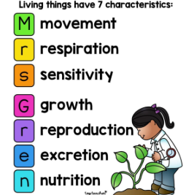  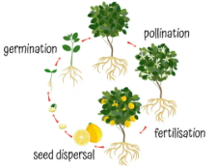  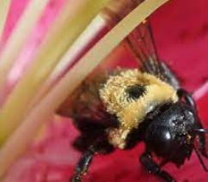  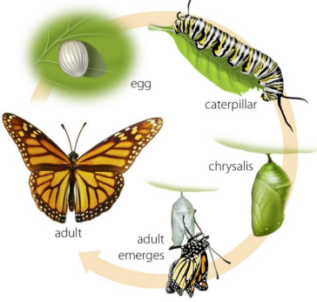  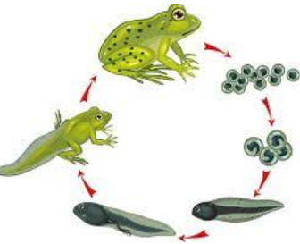 | Key words:
  egg | female reproductive cell
  fertilise | create new life
  life cycle | the series of changes in a lifetime
  live young | not hatched from an egg
  metamorphosis | the process of transformation from immature to adult
  reproduce | produce offspring by sexual or asexual process
  life processes | the essential things that all living things do
  sperm | male reproductive cell
Did you know?
- Not all plants have flowers.
- Not all plants start as a seed.
- Not only birds lay eggs.
- Plants are living.
- Minibeasts are a category of animal.
 |  | 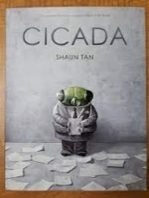  Exciting books/web links:  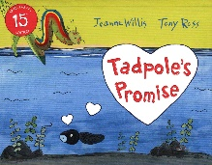  https://www.bbc.co.uk/teach/class-clips-video/science-ks2--ks3-the-life-cycles-of-different-organisms/zvh8qp3 | Parents as partners:  Investigate which plants don’t grow from a seed.  Discover which animals are minibeasts.  Discuss which other animals might lay eggs.  Ask your child to describe the life cycle of an animal they have been learning about.  Draw the life cycle of a butterfly.

