 | D&T Structures: Bridges
 | Year Group: 5 | Subject Focus: DT | Term: Spring 1
Key facts:  - A bridge is a structure that allows people and vehicles to cross over an open space. Bridges span, or stretch across, deep pits in the Earth, bodies of water, and roads!  - A beam bridge is the oldest, simplest, and most common type of bridge.  - The arch bridge is another old type of bridge, arch bridges often span rivers.  - Some type of bridges are moveable. Some can lift upwards allowing tall ships to pass.  - Over time, bridges have been made from four main materials: wood, stone, iron, steel and concrete.  - Early humans built the first bridges from logs, branches or stones. They also made suspension bridges with long, tough vines. |  | Technical Knowledge:  Here are the structures of four popular bridge designs:  Truss Bridge: a bridge made from a series of triangular beams.  Beam Bridge: a bridge which is built with horizontal beams and vertical pillars.  Suspension Bridge: a bridge which is supported by vertical cables and suspended by cables which run between pillars that are connected onto either end of the bridge.  Arch Bridge: a bridge which is build with a curved arch.  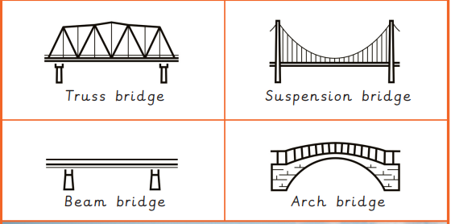  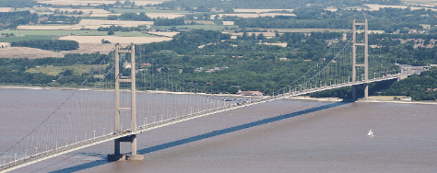 | Key words:  .  Real life:  The Humber Bridge in Hull is one of the longest single span suspension bridges in the world, which allows cyclists and pedestrians too.  Whitby Swing Bridge is a pedestrian and road bridge over the River Esk in Whitby.
  Truss Bridge | A bridge made from a series of triangular beams.
  Beam Bridge | A bridge which is built with horizontal beams and vertical pillars.
  Suspension Bridge | A bridge which is supported by vertical cables and suspended by cables which run between pillars that are connected onto either end of the bridge.
  Arch Bridge | A bridge which is build with a curved arch.
  shape | The form of an object
  structure | Something which stands, usually on its own
  reinforce | To make a structure stronger
  accurate | Neat, correct shape, with no mistakes
  tension | A stretching force where two structures are pulled apart
  assemble | To fit together the separate parts of something

