 | Whitby: A Coastal Study |  |  | 
 | Year Group: 5 | Subject Focus: Geography | Term: Spring 1
Key facts  - Whitby is a coastal town in North Yorkshire that is very different to Leeds.  - It is close to the North York Moors National Park.  - The earliest record of a permanent settlement at Whitby is in 656 when the Christian king of Northumbria built an abbey there.  - Today, the town is built on both sides of the River Esk and is popular with tourists.  - It has many physical and human geographical features which make it popular with tourists.  - Around 13000 people live in Whitby.  - The houses are built of brick or stone, often with red pantiled roofs, in narrow, steep streets, on both sides of the river.  - There is a swing bridge spanning the River Esk that joins the east and west sides of the town.  - Whitby is part of the coastline known as the 'Dinosaur Coast', the 'Fossil Coast' or the 'Jurassic Coast', that stretches from Staithes in the north, to Flamborough. At Whitby, dinosaur footprints are visible on the beach and the rocks around Whitby contain fossils, which include ‘Whitby Jet’. |  | 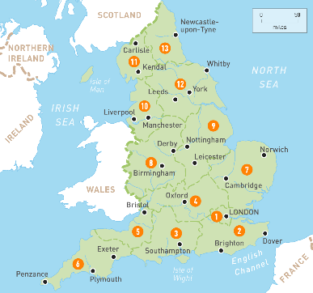  Whitby is a seaside town, port and civil parish in the Scarborough borough of North Yorkshire.  Tourism started in Whitby during the Georgian period and developed with the arrival of the railway in 1839.  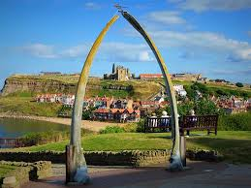  Whaling was a massive industry between 1750 and 1840. The whalebone arch on top of West Cliff reminds us that Whitby was once a whaling port. | Key words:
  bay | Where the shore curves inwards
  coast | The seashore
  dune | A mound of sand shaped by the wind
  deposition | Laying of sediment carried by the wind
  erosion | Wearing away of the earth’s surface
  harbour | A place where boats can shelter
  headland | A piece of land jutting out into the sea
  settlement | A small number of people or homes in a new area
  stack | A steep vertical column formed by wave erosion
  stump | Land left when the main part is worn away
Did you know?
- Whitby Abbey was the inspiration for the writer Bram Stoker who wrote Dracula in the town.
- The famous explorer Captain Cook learned how the sail in Whitby Harbour.
- Smugglers thrived in North Yorkshire coastal towns like Whitby. Rum and brandy arrived by sea away from the watchful eye of the taxman.
- One of the most famous landmarks in Whitby are the 199 Steps that lead up to St Mary’s Churchyard, also known as the ‘Church Steps’.
 |  | Exciting books/ web links:  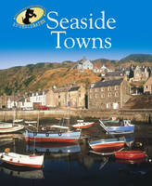     | Parents as partners:  - Encourage your child to create some amazing fact cards about Leeds and Cross Gates.  - Together, make a poster comparing Leeds and Whitby.  - Create a word search or crossword about the Whitby  - If you could visit Whitby, what would you do? Look on line and create an itinerary for a weekend visit. How many different activities could you include?  - Find out how fossils are formed.

