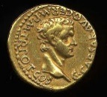 | The Romans |  |  | 
 | Year Group: 4 | Subject Focus: History | Term: Spring 1
Key facts:  - There were around five thousand soldiers in a Roman Army legion.  - Before the Romans arrived, Britain had no real roads.  - The Romans invaded and conquered many countries in Europe before heading to Britain.  - Boudicca was a Celtic Queen.  - Scotland was known as Caledonia.  - The Romans left their mark on Britain leaving us with new towns, plants and ways reading and counting.  Timeline:  55 BC – The first raid  The Roman General Julius Caesar came across the sea to Britain. He brought with him two Roman legions as he wanted to make Britain a part of the Roman Empire.  54 BC – The second raid  A year later, Julius Caesar came back across the sea. This time, he brought with him five legions and two thousand cavalrymen (soldiers who fight on horses).  AD 43 – The Romans returned  About one hundred years later, the Romans returned. Emperor Claudius was now in charge and he was determined to make Britain part of the Roman Empire.  AD 60 – Rebellion against Romans  Tribes, which were led by Boudicca, attacked the Roman forces.  AD 410 – Roman departure  Romans left Britain and returned to Italy. |  | 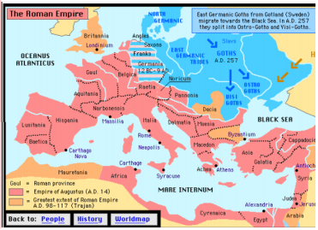  Map of the Roman Empire | Key words:  Key Themes  In our study of the Roman Empire, we will continually connect our learning to some of the overarching history themes of society, settlements and invasion.
  archaeologist | someone who studies the past by exploring old remains
  artefact | an object from the past that shows evidence of what life was like
  emperor | somebody who rules an empire or is the head of state in an empire
  empire | a number of individual nations that are all controlled by the government or ruler of one particular country
  infrastructure | the basic facilities such as transport, communications, power supplies and buildings which enable it to work
  invasion | to try and take over a place by force
  raid | a sudden armed attack against a place
  rebellion | fighting back and opposing the people who have attacked you
  Roman | related to or connected with ancient Rome and its empire
  settler/  settlement | people who migrate to a new place and when people start a community it is called settlement
Important people:
Emporer Claudius – first Roman emperor to successfully invade Britain
Julius Caesar – famous Roman leader who attempted to invade Britain
Boudicca – Saxon queen who fought back against the Romans
Paulinus – Roman governer (ruler) of Britain in AD 60
Romulus and Remus –mythical twin brothers and founders of Rome
Exciting books/ weblinks:
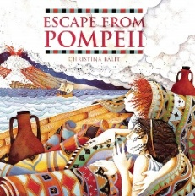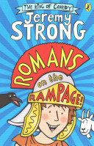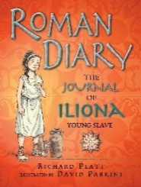

Parents as partners:
- Research life as a Roman (what did they wear, what did they eat?).
- Help your child make a model Roman villa.
- Together, use squared paper to design a Roman inspired mosaic.
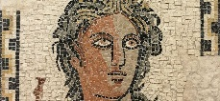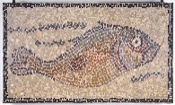

Did you know?
- The Romans are famous for their long, straight roads.
- Latin was the language spoken and written by the Romans.
- The Roman system for counting was based on seven different symbols: I, V, X, L, C, D, M.

