 | Art: Clay Pots
 | Year Group: 4 | Subject Focus: Art | Term: Spring 1
Key Knowledge:  - Clay is a natural material made up of tiny particles of rock. When mixed with water, it feels like soft, gluey mud and can be pinched, rolled, cut or built up in layers to form many different shapes.  - Clay holds its shape and hardens as it dries.  - Pottery is the art of making containers, sculptures and other objects of clay.  - Clay is shaped and then fired or baked at a high temperature, to harden it. Items created in this way are also called ceramics  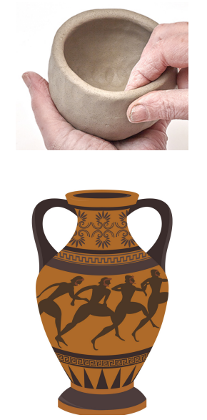 |  | Technical Knowledge:  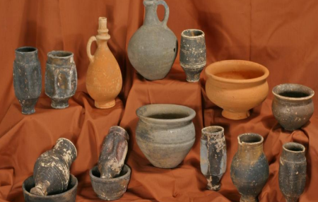  Romans used pottery for many of their everyday items. Roman pottery was influenced by ancient Greek pottery however Roman pottery often had decorations cut into it. By contrast, the ancient Greeks painted images on their pottery.  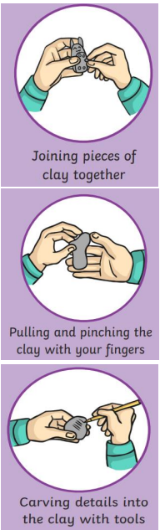 | Key words:  .  Quick Quiz  Can you name 3 different objects that are made out of clay?  Can you name an artist that uses clay and describe his or her work?  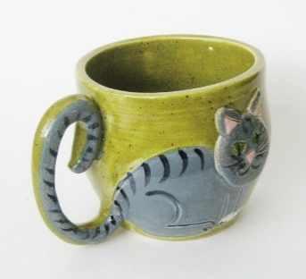  Can you explain three techniques that are used to mould clay into different shapes?
  Clay | a stiff, sticky fine-grained earth that can be moulded when wet
  Malleable | easily pressed into shape without breaking or cracking
  Pinching | squeezing between thumb and finger
  Sculpt | to make a form by carving, chiselling, modelling or casting
  Joining | to attach parts together
  Texture | how something feels when touched
  Ceramic | pots and other articles made from clay hardened by heat
  Carve | cutting to produce a design
  Sketching | a rough drawing to prepare
  Slip | a clay slurry used to produce pottery and other ceramic items
?

