 | Climate Change: What can we do to protect our future? |  |  | 
 | Year Group: 5 | Subject Focus: Geography | Term: Autumn 2
Key facts  Climate describes the weather conditions that are expected in a region at a particular time of year.  Climate change describes a change in the average conditions — such as temperature and rainfall — in a region over a long period of time.  Every day, approximately 8 million pieces of plastic pollution find their way into our oceans.  When too many fish are taken out of the ocean, it creates an imbalance that can erode the food chain and lead to a loss of other important marine life, including vulnerable species like sea turtles and corals.  Corals are, in fact, animals and not plants.  Pollution is damaging coral reefs which are very important for protecting coastlines from erosion and they provide a habitat for thousands of species of marine creatures. |  | 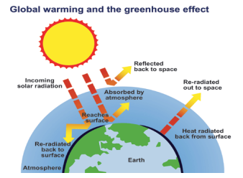  We will take a look at  what is happening to  our precious world. We  will see the effects that  everyday habits and  behaviours have on our  planet. We will  investigate to see if  we can do anything to reduce the damage we are causing.  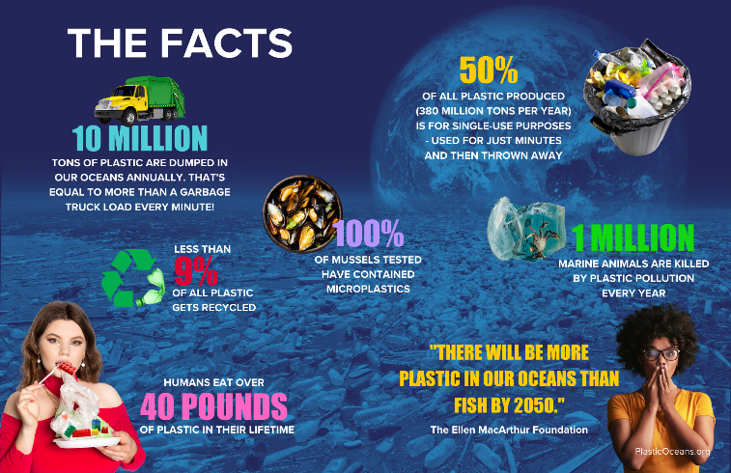 | Key words:
  biome | areas around the world that have a shared physical climate
  ecosystem | a community of living and non-living things in a specific area that interact with each other
  conservation | to save or protect something, to keep things the way they were
  coral | a hard, stony substance that is secreted by marine creatures and forms large reefs in warm seas
  endangered | to be seriously at risk of extinction
  habitat | the environment in which an animal or plant usually lives or grows
  macro | large scale
  micro | extremely small
  pollution | harmful or poisonous substances introduced to an area
  sustainability | to be maintained on for a long time
Did you know?
Since 1901, the sea level has risen by seven and a half inches.

There is now more carbon dioxide in our atmosphere than at any other time in human history.

The last decade was the hottest in 125,000 years.

A whopping 2 million plastic bags are used every minute worldwide.

Only 9% of all plastic produced is recycled.
 |  | 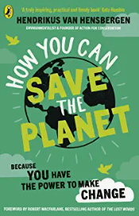  Exciting books/ web links:  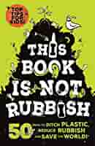  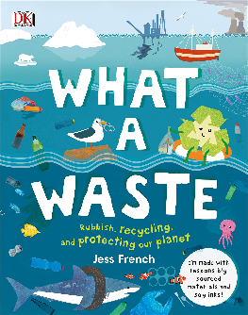 | Parents as partners:  As a family, see how you could reduce waste:  Could you recycle more of the things you throw away?  Could you recycle your old clothes or toys?  Could you make something new out of something you have used?

