 | D&T - Cooking and nutrition: developing a recipe
 | Year Group: 5 | Subject Focus: DT | Term: Autumn 2
Key facts:  Nutritional value helps us understand how healthy a food is. Nutrition information on food labels can help us make better choices for our bodies by showing us the amounts of nutrients like fibre, protein and sugar.  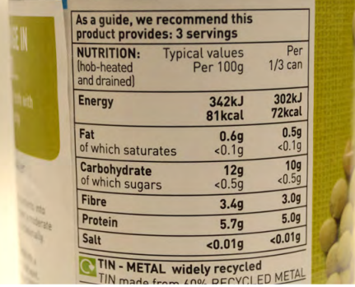  From Farm to Fork:  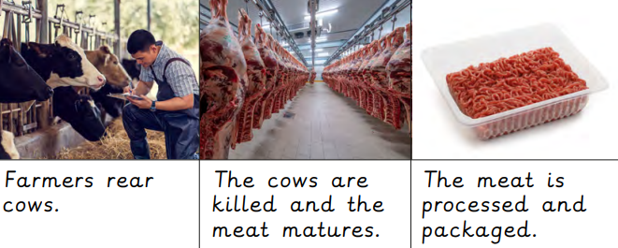  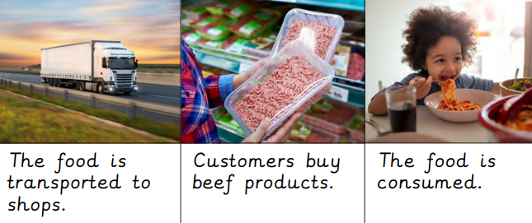 |  | Technical Knowledge:  Cross-contamination is when harmful bacteria from one food get onto another. To prevent it, use different coloured chopping boards for different types of food.  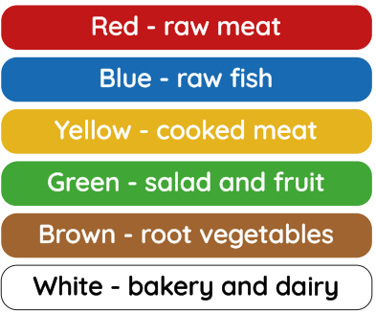  Cooking symbols/techniques that we will use:  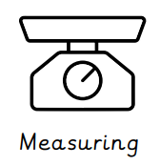  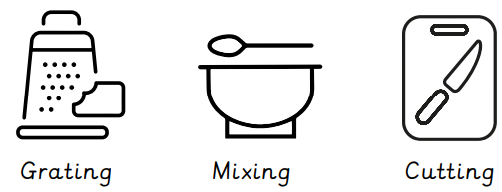  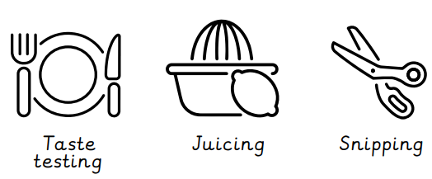 | Key words:  .  Real life:  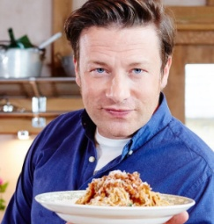  Spaghetti bolognese is a popular dish here in the UK enjoyed by many. It can be adapted in many ways by adding, substituting and removing ingredients to ensure that it suits dietary needs and tastes. A famous chef here in the UK who has cooked many variations of spaghetti bolognese is Jamie Oliver - an English, celebrity chef.  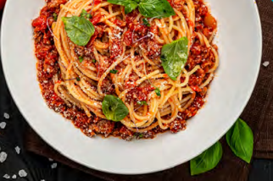
  adaptation | the process of changing something.
  cook | to prepare food by heating it.
  cross-contamination | when something harmful spreads from one food to another.
  farm | to grow crops or keep animals as a business.
  hygiene | keeping things clean to prevent illness.
  ingredients | the foods a recipe is made from.
  label | something that provides information about the product it is attached to.
  nutrient | substances that help living things stay healthy and grow.
  nutritional value | the nutrients a food or recipe provides.
  process | a series of actions.

