
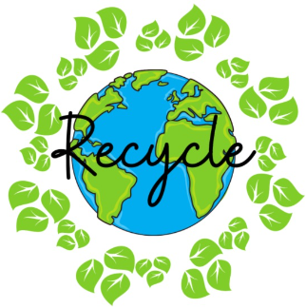
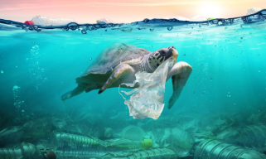

https://www.google.com/url?sa=i&url=https%3A%2F%2Fwww.etsy.com%2Fuk%2Flisting%2F1477679581%2Fsummer-png-transparent-non-transparent&psig=AOvVaw2fl3BkaGXQlJgCJKfQLgXZ&ust=1748794312520000&source=images&cd=vfe&opi=89978449&ved=0CBQQjRxqFwoTCKCritCMzo0DFQAAAAAdAAAAABAE
HOMEWORK - Please ensure that your child practises words from their spelling lists, reads daily for 10 minutes and completes online learning tasks such as TTRockstars, purple-mash and mathsbot! Homework is due on a Friday.
PE – We are continuing swimming lessons this term on a Monday afternoon. Please ensure your child comes to school with their swimming costume/shorts and brings a towel. PE this term is on a Wednesday. Please ensure your child wears their PE kit on this day with appropriate trainers. All long hair must be tied up and jewellery must be removed during PE.
At the end of this term, we will be performing our showcase assembly!
More information to come in due course!
French: We will be learning months of the year, days of the week, and how to ask and say our birthdays!
RE: We will be continuing to learn about Judaism, and the many Jewish festivals.
Computing: We will be learning about coding, and how to use scratch.

DT: We will be focusing on cooking and nutrition. The children will be planning and preparing to cook a healthy spaghetti bolognese – yum!
Music: ‘Rhythmic Robots’, exploring body composition, and different ways to make music!

Geography: In Geography this term, our topic is Climate Change! We will be learning about the effects of pollution on our planet and climate change. We will also learn about recycling, and how to look after our animals and world.
PSHE: We will be learning about keeping safe and managing risks.
Science
Our science topic this term is ‘Forces’. This is an exciting topic where we will learn all about the discoveries of Sir Isaac Newton, and his theories about gravity. We will also experiment with air resistance and water resistance. Finally, we will learn about levers, pulleys and gears.

Dear Parents and Carers,

Welcome to the start of the new term – Autumn 2, I hope you have had a restful half term break and your child is looking forward to the next half term in Year 5!

Year Five
Newsletter
November 2025

Maths
In Maths, we will be learning how to multiply and divide integers by 10, 100 and 1000. We will then be starting fractions, where the children will learn about improper fractions and mixed number fractions, and how to convert, add and subtract. On top of this, the children will be continuing with mastering number sessions and weekly arithmetic.

In English and Reading

We will be studying the book ‘This Book is Not Rubbish’, which links closely to our topic. We will plan and write a diary about the day in the life of a plastic bottle, which will include ambitious vocabulary, cohesion and many of the year 5 grammar expectations. We will also learn how to write instructions on how to make something recycled!

