 | Forces |  |  | 
 | Year Group: 5 | Subject Focus: Science | Term: Autumn 2
Key facts:  All forces are a push or a pull.  Forces can be indicated with arrows showing their direction.  On Earth, gravity is the force pulling all objects towards the centre of the Earth.  Air resistance and water resistance are examples of friction.  Air resistance causes objects moving through air to slow down.  Water resistance causes objects moving through water to slow down.  Friction is the force created by two objects, materials or surfaces rubbing together.  Friction causes objects to slow down or stop.  Some forces are stronger than others and can overcome them when they are in opposition eg: gravity overcomes air resistance when a parachute falls to Earth.  Levers, pulleys and gears can allow smaller forces to have greater effect. |  | 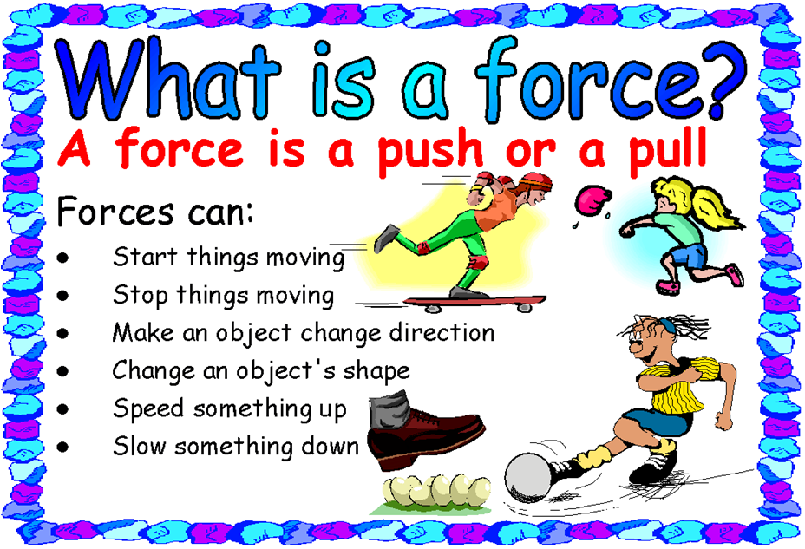  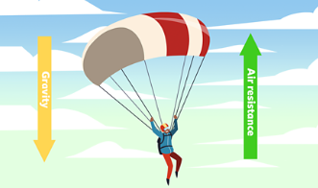 | Key words:
  Newtons (N) | the unit of measurement for force, named after Sir Isaac Newton
  gravity | the force that attracts to the centre of the earth
  resistance | a force that opposes or slows down motion
  friction | the resistance that a surface or object meets when moving over another surface or object
  mechanisms | parts of a working machine
  drag | a force that opposes movement through a fluid (air or water)
  levers | a simple machine to increase force
  pulleys | mechanisms using a wheel and rope for moving objects
  gears | a simple machine to create movement
  upthrust/buoyancy | an upward force allowing an object to float
Did you know?
Lots of different civilisations have used levers, pulleys and gears to make things move.

Everything that moves, involves a force.

Your trainers are designed in order to create friction.

A see-saw is a type of lever.

 |  | Exciting books/web links:  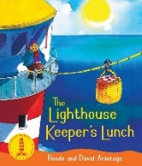  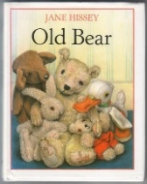  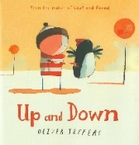  https://www.bbc.co.uk/teach/terrificscientific/KS2/zr63d6f  https://www.bbc.co.uk/bitesize/topics/znmmn39 | Parents as partners:  Investigate any forces that you might find in your home.  Which forces might you encounter on your journey to school every day?  Discuss what might happen if there was no gravity on earth.

