 | DT: Mechanisms (Wheels and Axis)
 | Year Group: 1 | Subject Focus: DT | Term: Autumn 2
Key facts:  How do wheels move?  The wheels need to be round to balance the body of the vehicle.  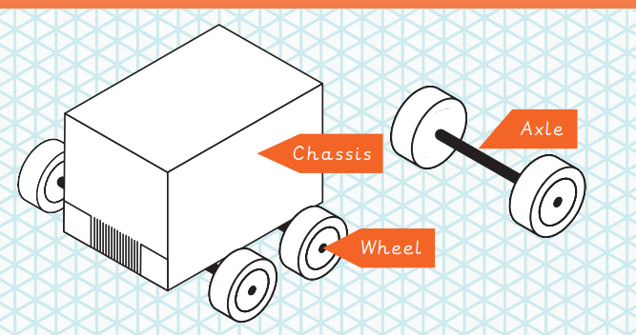  Wheels are everywhere in life. Have you seen any of the wheels below?  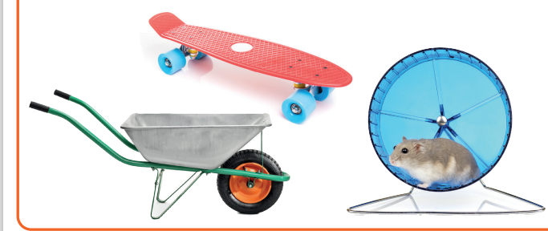  We Are Learning To:  - Make a moving vehicle with working wheels and axles.  - Explain that wheels move because they are attached to an axle.  - Recognise that wheels and axles are used in everyday life, not just in cars.  - Explain what must be changed if there are any operational issues.  - Design a vehicle that includes functioning wheels and axles. |  | Technical Knowledge:  The wheel needs to be attached to the axle. The axle needs to fit inside the axle holder but must not be attached to the axle holder otherwise the wheels will not turn properly.  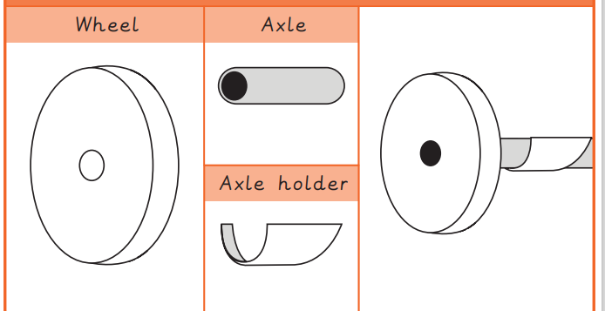  The body of the car is called a chassis. The chassis needs to be properly secure so then the wheels fit onto them tightly.  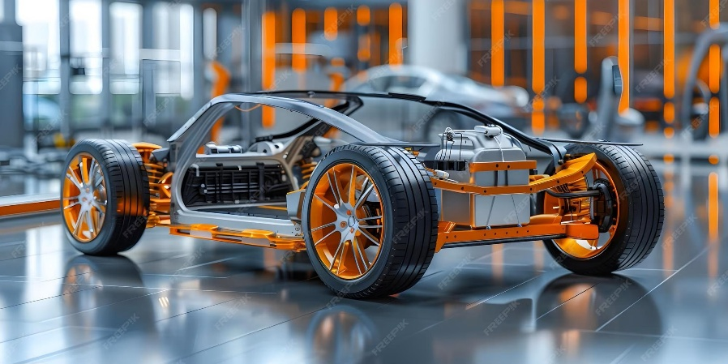 | Key words:  Real life:  Elon Musk founded Tesla, an electric car company which specialises in making cars better for the environment.  
  axle | A long, straight rod that connects to a moving part.
  axle holder | The part of a mechanism that holds the axle steady.
  accurate | Neat, correct shape, size and pattern with no mistakes.
  chassis | The body of a car.
  model | A practice version that lets you test out your idea.
  mechanic | A person who can build or mend vehicles with other machines.
  mechanism | Parts of an object that move together to make something work.
  wheel | .A circular object that turns around.
  design | To make, draw or write plans for something.
  fix | To mend something so that it will work again.

