 | Uses of everyday materials |  |  | 
 | Year Group: 1 | Subject Focus: Science | Term: Autumn 2
Key facts  • Objects are made from materials. Some  common materials are wood, plastic, metal,  glass, rock, fabric and paper.  • Some objects are made from more than one  material.  • Different materials have different properties  which makes them suitable for different  purposes.  • Materials can be hard or soft, dull or shiny,  bendy (flexible) or not bendy (rigid),waterproof or not, rough or smooth. |  | Our Learning Journey:  We Are Learning To…  - Identify and name a variety of materials  - Describe the physical properties of different materials  - Investigate the properties of different materials  - Compare and group together a group of materials based on their properties  - Describe the material different objects are made from.  Our five enquiry types:  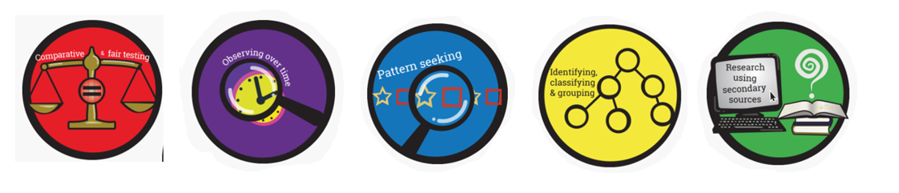  Working Scientifically Skills:  In this unit we will be:    Asking Questions    Making Predictions    Observing    Interpreting and Communicating Results    Evaluating | Key words:
  Material | A substance from which something is made from
  Rough | Harsh or uneven to touch
  Fabric | Is cloth or other material produced by weaving cotton together
  Waterproof | something which keeps out water
  Hard | Not easy to bend, cut or break
  Soft | Not hard or firm
  Object | A material thing that can be seen and touched
  Fragile | Easily broken or damaged
  Smooth | Having no roughness or imperfections you can feel with your hands.
  Absorbent | A type of material which can soak up liquid
Exciting books/ web links:

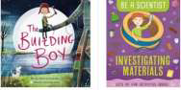

https://www.bbc.co.uk/bitesize/topics/zrssgk7
https://www.lego.com/en-gb/kids
Parents as partners:

• Look at your toys at home. Which are your favourites? What are
they made out of?
• Why do you think certain toys are made out of a certain material?
What would happen if they were made out of something different?
• Complete a materials hunt around your house. How many different
materials can you find? Can you describe their properties?

