Year 3 Newsletter (Autumn 2)

I hope you had a well-rested break and are ready for this half term!
Our learning journey
History  In history, we will travel through the Stone Age, Bronze Age and Iron Age looking at the impact from each age. We will explore what humans needed to survive during these times as well as their clothing, weapons, houses and how they have changed to now.  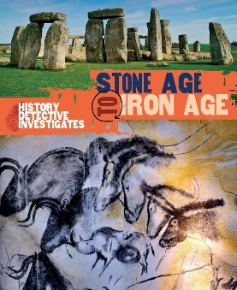 | Science  In science, children will build on their knowledge and understanding of rocks, fossils and soil. They will name different types of rocks and learn how they are formed. Children will be able to explain the difference between types of rocks. We will learn about fossils, what they are and how they are formed. We will plan and carry out experiments to group the different types of rock.  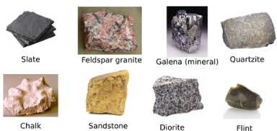 | Maths  This half term in Maths, our learning will continue to focus on addition and subtraction of 3-digit numbers across 100. These will continue to include exchanging across 10s and 100s. We will then be moving on to our multiplication and division where we will recap our 2, 5 and 10s before moving on to learning 3, 4 and 8s!  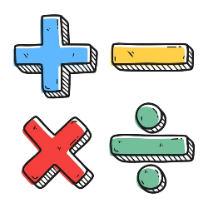 | English and Reading  This half term, we will finish our reading of ‘Tilly and the Time Machine’. In English, we will be focusing on the story ‘Stone Age Boy’ which we will write our own narrative based on the story. Continuing with our Stone Age theme, we will then look at instructions and will be writing ‘How to Wash a Woolly Mammoth’.  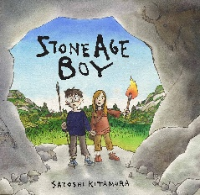

Other:  - PE days are on a Monday and a Tuesday. If your child wears earrings, please make sure that they are taken out or covered before school on these days.  - Tuesday 26th – Wednesday 27th November – Parents Evening.  - Friday 5th December – Open Doors Afternoon.  - Friday 12th December – Christmas jumper, dinner and fair day.  - Tuesday 16th December – Carol concert at the Church. | Class routines:  - The children are expected to read at home every night. Reading records and books should be brought to school every day so that a member of staff can read with them in school. These reading books will be changed on a Friday if the reading record has been signed.  - Each Friday, the children will complete a spelling quiz. Spellings will be sent home of a Friday and should be practised at home.  - Pupils should continue to log onto TTRockstars to improve their times tables knowledge. This can be done through ‘Jamming’ focusing on our 2,3,4,5,8 and 10 times tables.

Finally, please remember to log onto the class page on the school website to keep up to date with our latest news: https://www.crossgatesprimary.co.uk/class-pages/ or by accessing the school twitter page.
Miss Croft

