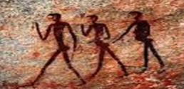 | Stone Age to Iron Age |  |  | 
 | Year Group: 3 | Subject Focus: History | Term: Autumn 2
Key facts  - The Stone Age began 4 million years ago when the first humans lived in Africa.  - It began when the first tools were made from stone and ended with the introduction of metal tools.  - At the end of the Ice Age, the sea levels rose and so Britain turned into an island.  - Humans survived by using sharp stone tools to kill animals. They ate meat from the animals and fish they caught in the rivers. They gathered food and berries.  - The first people arrived in Britain over 700,000 years ago.  - Our ancestors painted on caves in France and Spain. They thought of these caves as special places.  - They made tools out of flint, bones and wood.  - The Bronze Age started when the Beaker People arrived from Europe.  - They brought with them new ways of making metal.  - Bronze Age people lived in settlements, which were made of a group of round houses.  - Houses were made from wattle (sticks) and daub (mud) or dry stone.  - Settlements traded resources like copper and tin.  - During the Iron Age, tools were made from iron.  - Settlements became larger because tribes were better able to farm and defend themselves. |  | 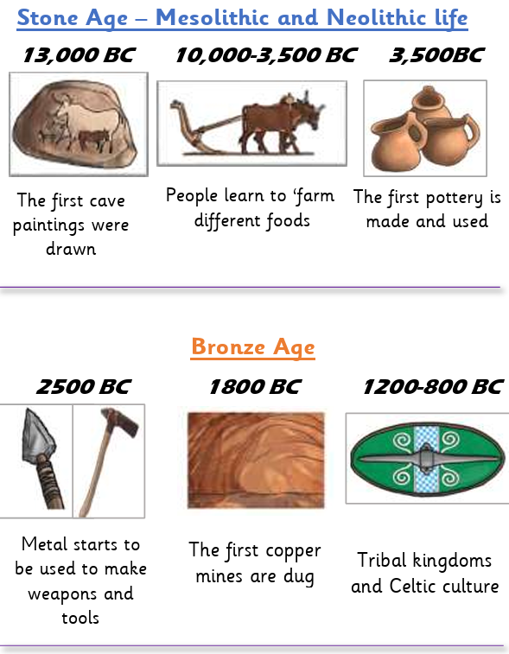  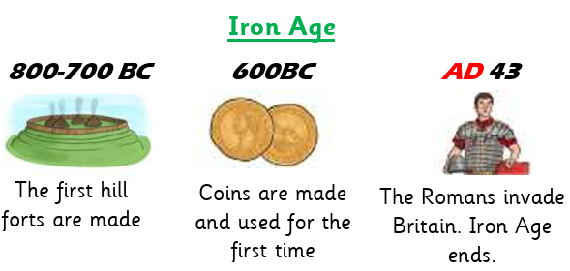 | Key words:  Key Themes  We will continually connect our learning to two of the overarching history themes of society and settlements.
  ancient | Belonging to the very distant past.
  archaeologist | A person who studies the lives of people who lived in the past.
  artefacts | Objects made by human beings.
  bronze | A metal alloy made from a mixture of copper and tin. It is a much harder and more long-lasting material than stone or copper alone.
  monarchy | A type of government where a king, queen, or emperor is the head of state
  Mesolithic | The middle Stone Age. Hunter gathers began to use farming methods and store food.
  Neolithic | The later part of the Stone Age when people began to trade.
  Palaeolithic | This began when they first made tools using stone.
  sacrifice | To give something up, break it or kill it as an offering to a god or gods.
  settlement | A place, typically one which has previously been uninhabited, where people establish a community.
Key people/ places
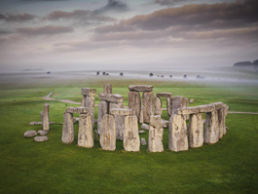
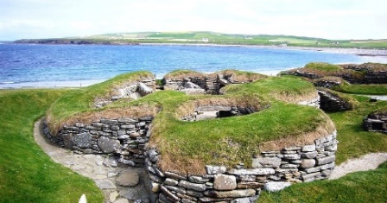
Skara Brae
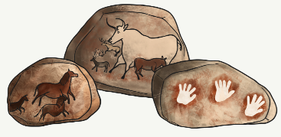
Stonehenge

The Lascaux caves in France
 |  | Exciting books/ web links:  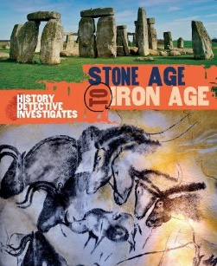  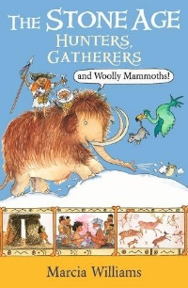 | Parents as partners:  - Encourage your child to create some amazing fact cards about life in the Stone Age.  - Support your child to create a model of Stonehenge or a roundhouse. Can you find a way of showing what it was like inside?  - Create a word search or crossword about Stone Age.  - Find out what artefacts can be found in the British Museum.

