 | DT: Cooking and Nutrition (Eating Seasonally)
 | Year Group: 3 | Subject Focus: DT | Term: Autumn 2
Key facts:  Seasonal means foods that grow in a given season in a given country.  Some seasonal foods that grow in the UK and what season they grow in.  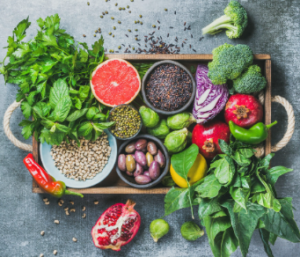  Eating seasonal foods can have a positive impact on the environment.  Similar coloured fruits and vegetables often have similar nutritional benefits.  We Are Learning To:  - Explain why food comes from different places around the world.  - Explain the benefits of seasonal foods.  - Develop cutting and peeling skills.  - Evaluate seasonal ingredients.  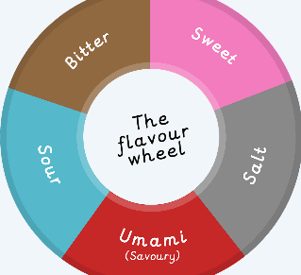  - We will eventually be designing and making a seasonal tart. |  | Technical Knowledge:  Cutting and Peeling:  - National Curriculum  Pupils should be taught to:  Select from and use a wider range of tools and equipment to perform practical tasks [for example, cutting, shaping, joining and finishing], accurately.  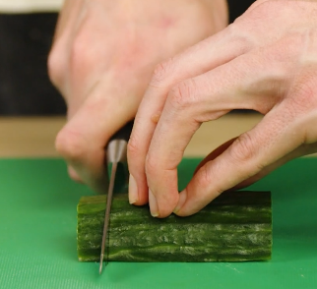  Claw Grip  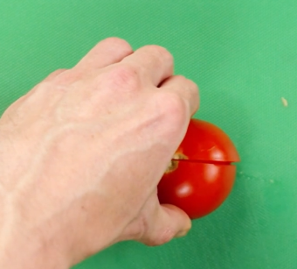  Bridge Hold  - Identifying seasonal ingredients from the UK.  - Tasting seasonal ingredients and describing the texture and flavour.  - Peeling foods by hand or with a peeler and cutting ingredients safely. | Key words:  .  Real life:  Increasingly people are trying to eat more sustainably, in Britain we're lucky enough to grow some fantastic fruit and vegetables, but do you know what’s in season this month?  In November – December (the months we will be learning about eating seasonally) foods grown in the UK are: apples, cranberries, elderberries, pears, beetroot, brussel sprouts, butternut squash and cabbages.
  appearance | How something looks.
  cut | To use a sharp tool to divide, separate, or shape something.
  peel | To take off the outer skin or covering of something.
  design | A plan for something.
  evaluate | To weigh up the positives and negatives of something.
  export | To send (goods or services) to another country for sale.
  import | To bring (goods or services) into a country from abroad for sale.
  ingredients | Foods that a recipe is made from.
  mock- Up | A model of how something might look.
  seasonal | A food that is only available at a certain time of the year.

