 | Rocks
 | Year Group: 3 | Subject Focus: Science | Term: Autumn
Key facts  - Rocks can have a range of properties, including shiny, dull, hard, soft, rough, smooth, absorbent and impermeable.  - Rocks can also be sorted according to whether they have crystals or bubbles visible in them.  - Fossils are formed when things that have lived are trapped within sediment that turns into rock around the fossil.  - Over time, the bones of the dead animal dissolve and are replaced with stone, creating a fossil.  - Soils are made from rocks and organic matter (parts of dead animals and plants). Different soils have different properties depending on their composition. |  | 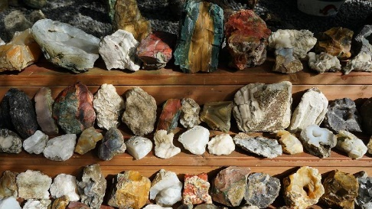  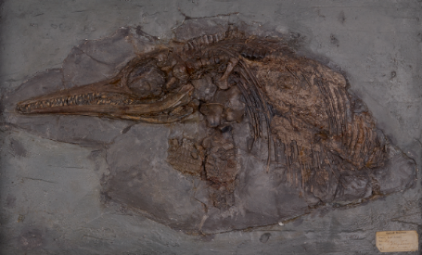  Our Learning Journey about Rocks:  - To compare and group rocks according to how they look and feel.  - To understand that different types of rocks have different physical properties.  - To know how fossils are formed.  - To know what soil is made of. | Key words:
  rock | a natural material made from one or more minerals
  crystals | more defined pieces observed in rocks
  layers | the different types of rock on the face of the earth are layered on top of each other and these layers can be studied
  permeable | takes in or soaks up liquid/fluid
  igneous | these rocks form when hot molten lava cools and hardens
  sedimentary | These rocks form as sediments build up in low-lying areas such as at the bottom of lakes and oceans, and in deserts.
  metamorphic | rocks that start out life as igneous or sedimentary rocks which are transformed over time by extreme heat or pressure, or both
  fossil | the remains of animals or plants that have been preserved between the layers of rock on Earth
  flesh | the soft part of a person/animal between the skin and bone, also the soft part of a plant
  minerals | make up Earth’s rocks, sands and soils
Did you know?
The oldest rocks on the planet are 4.28 billion years old! These rocks were discovered in the Acasta Gneiss complex in Canada’s Northwest Territories.
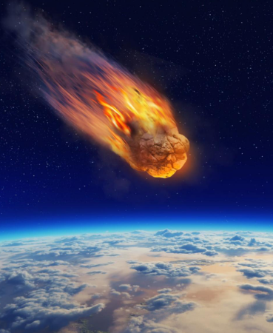
However, some meteorites that have landed on earth from space are even older, at around 4.6 billion years old!

 |  | Exciting books / web links:  BBC Bitesize – Types of rock:  https://www.bbc.co.uk/bitesize/articles/zgj9r2p#zycnn9q  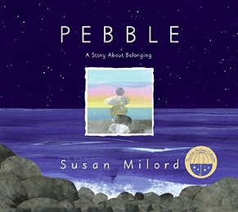  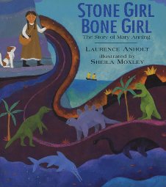  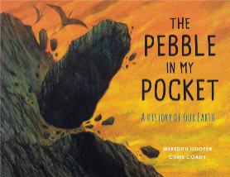 | Parents as partners:  - Do you have a special rock at home? Did you collect it somewhere special or find it whilst out exploring? Bring it in to school to share with us.  - Become a geologist and go on a rock hunt! Can you find three different rocks whilst out and about? Compare their appearance and discuss any similarities/differences.  - Take a walk through the local area/churchyard - can you find examples of where rocks have changed over time?  - Write a fact file or sketch a picture of Mary Anning and her discoveries.

