 | Uses of everyday materials |  |  | 
 | Year Group: 2 | Subject Focus: Science | Term: Autumn 2
Key facts  - Materials can have a number of different properties. They are chosen for various uses based on their properties.  - Materials can be hard or soft, shiny or dull, rough or smooth, flexible (bendy) or rigid (not bendy), waterproof or permeable and opaque, translucent or transparent. |  | Our Learning Journey:  We Are Learning To…  Investigate what we already know about every day materials- linking back to our Year 1 learning.  Identify materials of different objects.  Investigate how solid objects can be altered to change their suitability for a purpose.  Identify the use of everyday materials and their suitability.  Our five enquiry types:  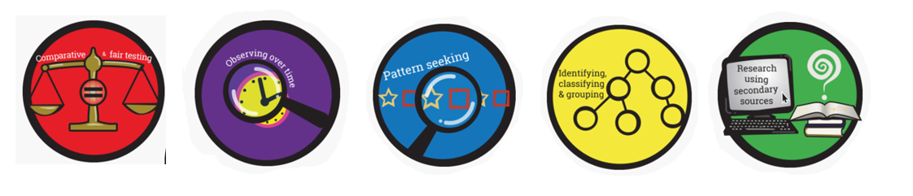  Working Scientifically Skills:  In this unit we will be:    Asking Questions    Making Predictions    Observing    Interpreting and Communicating Results    Evaluating | Key words:  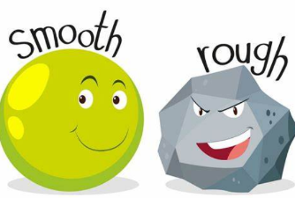  Transparent Opaque  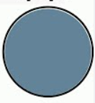  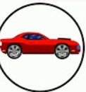
  opaque | Not letting light pass through. For example, if transparent materials let light through (such as windows), opaque surfaces do not (for example curtains).
  transparent | Letting light pass through and giving a clear view of objects at the other side. For example, windows.
  translucent | Light is allowed to pass through, but you cannot see clearly through the object.
  reflective | Light bounces from an object.
  non-reflective | Light does not bounce from an object.
  rigid | Unable to bend or forced out of shape.
  flexible | Bending easily without breaking.
  stretch | Make something longer or wider.
  bend | Change something that is straight into a curve.
  twist | Holding an object and turning your hands in opposite directions.
Key people
William Addis – Toothbrush inventor
Charles Mackintosh – Invented the waterproof coat, Mackintosh raincoat named after him
John MacAdam-Roads Chester – invented earmuffs.
Exciting books/ web links:

Centrally Heated Knickers – Michael Rosen (poetry book)

Little Lumpty – Miko Imai

Santa is Coming to Leeds – Steve Smallman

Aliens Love Underpants – Claire Freedman
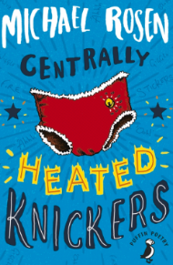
The Three Little Wolves and the Big Bad Pig – Eugene Trivisas
Parents as partners:
Could your child investigate what material their toys/clothes are made out of?
What is their favourite material? What properties does it have?
What different materials can you find in your home?
Imagine a world without wood/metal/plastic, could your child draw what their life may look like?

