
Year 2 Autumn 2 Newsletter
We have another very busy and exciting half term ahead of us in Year 2.
In Maths, we will be working on addition and subtraction, and we will be continuing to count in 2s, 5s and 10s. As we start to use these facts to learn the times tables, it would be helpful if you could support your child with this. There are times tables posters available in shops such as ‘The Works’ that can help with your child’s learning as well as TTRS.
In English, we will continue to develop our sentence writing and to improve the words that we use in our writing. We will be using ‘Traction Man’ as a stimulus, which is an exciting, action story. We will also be using ‘Superdad’s Day Off’ in our reading lessons.
In History, our study unit for this half term is all about the importance of the railways. The children will be learning about George Stephenson and what he invented. We have our educational visit planned to the National Railway Museum in York.
Science will see us exploring the uses and properties of everyday materials.
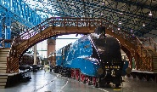
In other subjects, this is what we will be learning:
Computing – Spreadsheets

DT - Textiles
PSHE – Mental Health and Emotional Wellbeing
RE – Festivals
PE – Gymnastics and Agility
Music – Rhythmic phrases, harmonic patterns and dynamics
French – Greetings

As always, we will continue to encourage your child to read with you regularly at home as it has been proved that children who read regularly make the most progress.
The children will bring home spellings each week, usually on a Friday, that they will need to learn for a test the following Friday. We will appreciate your support with helping your child learn their spellings.
We would like to remind you that our PE days are Tuesdays and Fridays and that your child needs to wear their PE kit on those days. We would also request that, in line with school policy, any earrings are removed on these days. In line with school policy, other jewellery is not allowed to be worn in school.
It is essential that your child attends school every day, so that they can learn to their full potential.
We would like to thank you for your support.
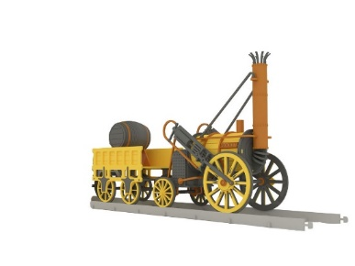
Mrs Austin, Miss Ali and Miss Lennon

