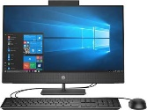 | Inventions |  |  | 
 | Year Group: 2 | Subject Focus: History | Term: Autumn 2
Key facts  - George Stephenson worked in a coal mine from being a child, and he never went to school. He taught himself how to read and write.  - He invented a locomotive, called The Rocket, to move coal around. In 1829, he entered a competition to invent a locomotive that would travel at 30 mph and he won!  - Trains became very important in Victorian times for travel and transport.  - Queen Victoria was the Queen of The British Empire from 1837.  - George Stephenson died in 1848.  - Queen Victoria died in 1901.  Themes explored in this unit of study;  Monarchy and Society |  | Parents as partners:  - Visit Thwaites Watermill, Temple Newsam Farm, Leeds Industrial Museum at Armley Mills, Leeds City museum or Abbey House museum to see how machinery has been used in Leeds for centuries.  https://museumsandgalleries.leeds.gov.uk/  - Go on the water taxi and see the waterways of Leeds and how they helped our city to grow. https://www.leedsdock.com/the-voice/leeds-dock-water-taxi/  - Walk to Cross Gates train station and watch some of the trains. Do they all look the same? How far do the trains travel?  Exciting books/ web links:  https://www.bbc.co.uk/bitesize/topics/zd4dy9q  https://www.bbc.co.uk/bitesize/topics/zn3vvk7/articles/zh7m8hv  https://www.bbc.co.uk/bitesize/topics/zn3vvk7/articles/zsydr2p  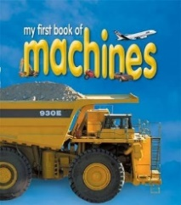  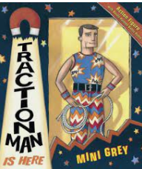  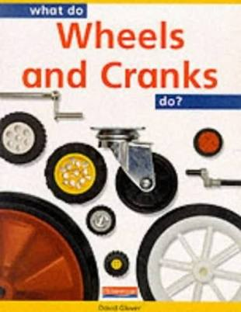  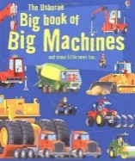 | Key words:
  achievement | a thing done successfully with effort, skill or courage
  chronology | the arrangement of events in the order they happened
  design | to make or draw plans
  diesel | an engine that uses fuel not steam
  era | a long and distinct period of history
  engine | a machine that uses energy from fuel or electricity to do work, such as to move
  event | a thing that happens or takes place, especially one of importance
  famous | known by many people
  first hand | directly experienced by somebody
  identify | find out about
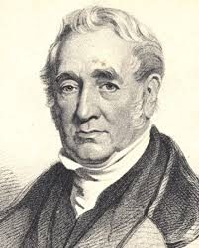

Key people/ places
George Stephenson was an inventor who invented ‘The Rocket’ – one of the very first trains.

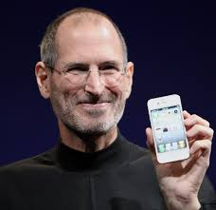
Steve Jobs was a designer and
inventor who created Apple
computers. He earned a lot of
money and gave lots of it to
charity.

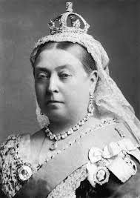
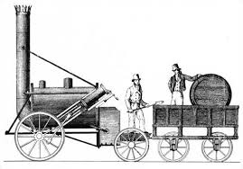

Timeline

                      
1819 1829 1837 1901 1930 2020

