 | DT: Textiles - pouches
 | Year Group: 2 | Subject Focus: DT | Term: Autumn 2
Key facts:  Sewing is good fun. Once you learn how to thread a needle and do a simple running stitch, you can make anything.  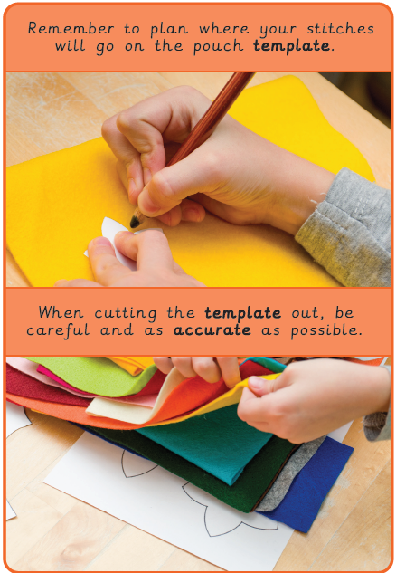 |  | Sewing is an important skill. Our clothes are usually sewn by machine but some are sewn by hand. Can you think of anything else that might be sewn?  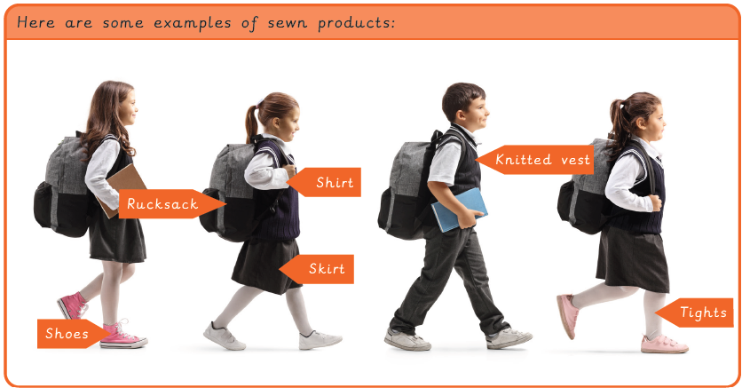  Top Tip:  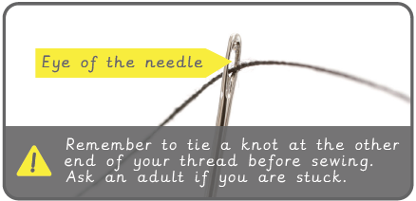 | Key words:  .  Real life: End results!  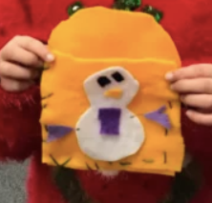  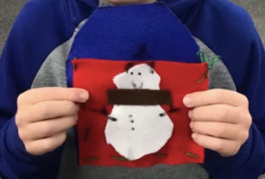
  decorate | Make something look more attractive by putting things on it.
  fabric | A natural, man-made or woven or knitted material.
  fabric glue | A special glue that sticks fabric together.
  knot | A join made by tying 2 pieces of string or rope together.
  needle | A thin pointed metal object with a small hole at one end for thread which is used in sewing.
  needle threader | A small sewing tool which helps to pull the thread through the needle.
  running stitch | A simple style of sewing in a straight line with no overlapping.
  sew | To join or fasten by stitches made using a needle and thread.
  template | A stencil which you use to help you draw a shape more easily on to different materials.
  thread | A length of a very thin fibre.

