 | DT: Slingshot Car
 | Year Group: 4 | Subject Focus: DT | Term: Autumn 2
Key Knowledge:  - To understand that all moving things have kinetic energy.  - To understand that kinetic energy is the energy that something (object/person) has by being in motion.  - To know that air resistance is the level of drag on an object as it is forced through the air.  - To understand that the shape of a moving object will affect how it moves due to air resistance.  Which vehicle do you think has the least air resistance?  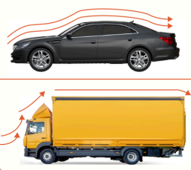 |  | Technical Knowledge:  - Mechanisms are a system of parts that work together to create a motion.  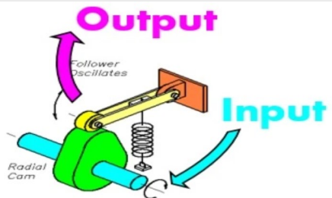  - There is an input and an output in a mechanism.  - Axles help wheels to move a vehicle.  Front View  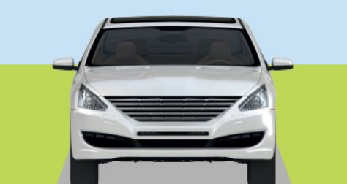  Side View  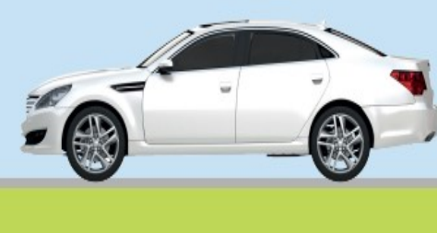  Bird’s-eye View  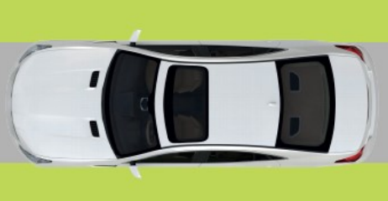 | Key words:  .  Real life:  Did you know?    Some of the first toy cars were made in 1901, that’s over 100 years ago!
  Axle | A bar with wheels that turns.
  Chassis | The body of a car.
  Air Resistance | The level of drag on an object as it is forced through the air.
  Design | To make, draw or plan for something.
  Slingshot | A Y-shaped toy used with an elastic band to shoot.
  Function | The purpose of an object or how the product works.
  Kinetic Energy | The energy that causes an object to move.
  Mechanism | The parts of an object that move together as part of a machine.
  Net | A flat 2D shape that can become a 3D shape once assembled.
  Structure | Something that has been made and put together and can usually stand on its own.
?

