 | Cross Gates |  |  | 
 | Year Group: 1 | Subject Focus: Geography | Term: Autumn 2
Key facts  - Cross Gates is a suburb in the city of Leeds. We are on the East of the city.  - Leeds is a city in England. England is one of the 4 countries that make up the United Kingdom. (England, Scotland, Wales and Northern Ireland.)  - Great Britain is an island which means it is surrounded by sea. (The North Sea, the Irish Sea and the English Channel.)  - There are many ways of travelling in Cross Gates including bus, train, car, walking, taxi, bike.  - There are many different types of buildings in Cross Gates. We have all kinds of housing, shops, banks, churches, schools, a fire station and a library.  - We can use maps, road signs and trusted adults to help us find our way if we are lost.  - When we are finding directions it is useful to know North, South, East and West.  - Atlases, globes, maps, plans and aerial photographs show us important features of a place. |  | 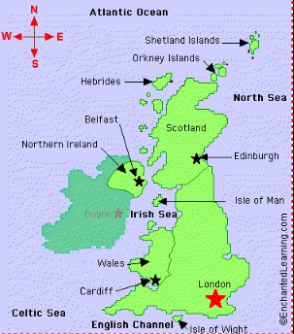  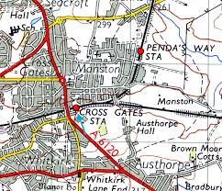  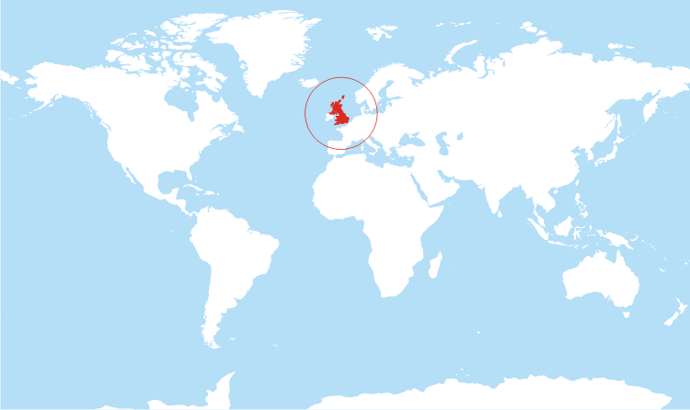 | Key words:
  aerial view | a view from above
  capital city | the city where the government sits. London is the capital city of England and the UK.
  city | a large town. London and Leeds are cities.
  compass  point | any of the main points of a compass: North, South, East and West
  country | an area of land that is controlled by its own government.
  island | a piece of land that is completely surrounded by water
  Great  Britain | An island that is made up of England, Scotland and Wales.
  town | an area with streets, houses, and buildings that is larger than a village but usually smaller than a city
  United  Kingdom | The UK is officially known as the United Kingdom of Great Britain and Northern Ireland. It includes England, Scotland, Wales and Northern Ireland.
  village | a small town or community, often in the country
  Country | Capital City | Flag | National Flower
England | London | 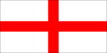 | rose
Scotland | Edinburgh |  | thistle
Wales | Cardiff | 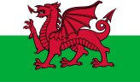 | daffodil
Northern Ireland | Belfast | 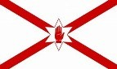 | shamrock
Key places:
 |  | Exciting books/ web links:  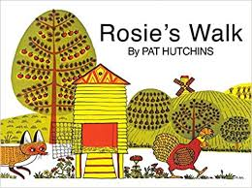  https://www.bbc.co.uk/bitesize/topics/zyhp34j/articles/z4v3jhv  https://www.bbc.co.uk/teach/class-clips-video/geography-ks1--ks2-cities-towns-villages/zjn492p  https://www.youtube.com/watch?v=RvDIZoQLgIE | Parents as partners:  - Go to Cross Gates train station and write a list of places you can travel to or look at the bus numbers and see where the buses go.  - Take the train or bus to Leeds and see how the city changes during the journey.  - Visit Cross Gates shopping centre and write a list of all the different buildings that you saw.  - Draw a picture of your house and label all the rooms.  - Ask a person who has lived in Cross Gates a long time if it has changed a lot whilst they have lived there. Can they tell you how?  - Visit one of our wonderful parks in Leeds. What can you see in the distance surrounding the park?

