It’s time for a new half term! I hope you had a lovely week break and you are all very excited about what this half term brings. We will be going on a local walk around Cross Gates to support our Geography learning, there will be lots of singing in preparation for our nativity and of course, lots of Christmas fun as the half term draws to a close!
Maths | English | Geography | DT
In Maths, we will be consolidating our addition knowledge before moving on to subtracting one number from another, up to 10. We will then be learning about 2D and 3D shapes. We will also be ensuring our numbers are formed correctly.  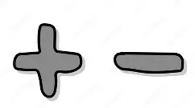 | In our writing lessons, we will be learning how to write a setting description based on the story “The Lonely Beast” by Chris Judge. We will be furthering our work by using “and” in our sentences and we will learn about what a verb is.  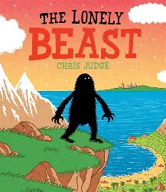 | In Geography, our focus is on the local area. We will be learning how to read a map and will create our own of a walk we will be going on around Cross Gates. We will be learning about what a city, village and country is and how big they are in relation to one another.  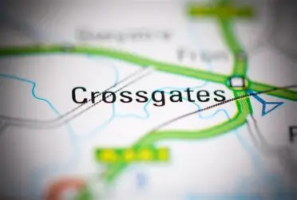 | In DT, we will be learning about mechanisms. We will be finding out how wheels move and will design, create and evaluate our very own cars!  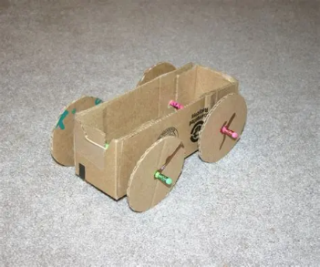

Important Information –  - Year One will have PE on a Wednesday and Thursday afternoon. Please ensure children come to school in their full PE kits on these days and any earrings they are wearing are taken out.  - Please regularly read with your child and write a comment in their book, informing us about how they have read and their successes.  - Key dates –  Parents evening: 25th and 26th November  Christmas Fair: 12th December at 2pm | Things to know –  - Each Friday, the children will complete a spelling test. Spellings will be sent home on a Friday and should be practised at home throughout the week.  - Reading records and books should be brought back on a Thursday and will be kept on a overnight to be changed. Please read with your child during the week and write a comment in their records.  - Children will return home on a Friday with a library book that they have picked – this should be returned on the following Thursday with their book bag.
Any questions you may have, please feel free to come and arrange a time to speak with me. Keep up to date with your child’s learning by going on to the school website and see what they have been busy doing! – Miss Robinson

