 | Temple Newsam |  |  | 
 | Year Group: 1 | Subject Focus: History | Term: Summer 2
Key facts  - Our local area has changed over time, and so have the lives of the people who live here.  - There have been lots of new inventions since the Victorian times. Lots of the activities that we like to do now did not exist around 100 years ago.  - We can compare the differences between life now and in the past by asking other grown-ups questions, reading books and using the internet to find out information.  Some key jobs at Temple Newsam house many years ago:  Servant  Butler  Maid / housekeeper  Nanny  Coachmen  Governess  Can you find out what these people would have done? |  | 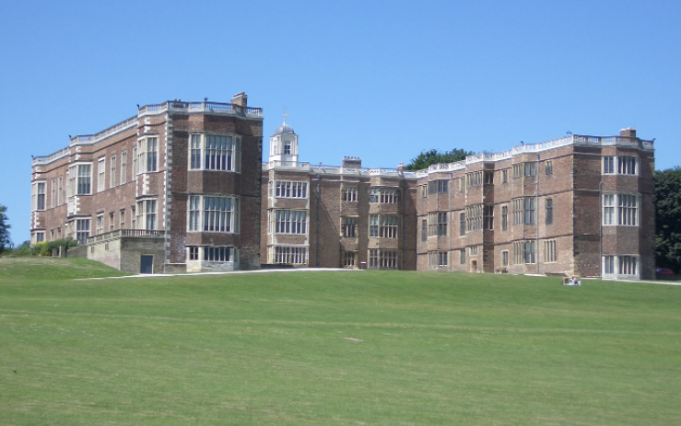  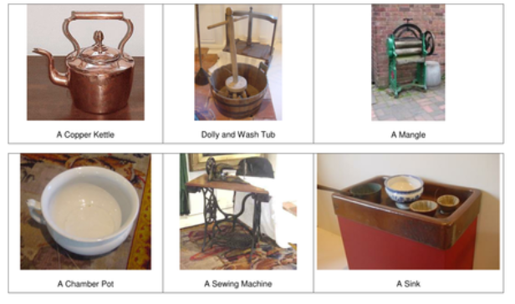 | Key words:
  Victorians | People who were alive when Queen Victoria was the Queen of England, from 1837-1901
  past | Something which has already happened
  present | What is happening now
  future | What will happen or is still to come
  modern | Things in recent times
  old | Belonging to the past
  era | A period of time beginning with some special date or event
  compare | To look at what is the same and different about two or more things
  decade | A period of ten years
  artefact | An item made or given shape by humans
 |  | Exciting books/ web links:  Learn how to play some Victorian games:  https://designsandlines.co.uk/the-best-victorian-playground-games-for-children/  https://www.bbc.co.uk/bitesize/subjects/zkqmhyc | Parents as partners:  - Visit Temple Newsam house, or look out for other Victorian buildings.  - Look at old family photographs together, and compare what looks the same and different to now.  - Discuss your toys and school life in the past, or ask older members of the family. What is the same? What is different?

