 | Textiles: Puppets
 | Year Group: 1 | Subject Focus: DT | Term: Summer 2
Technical Knowledge -  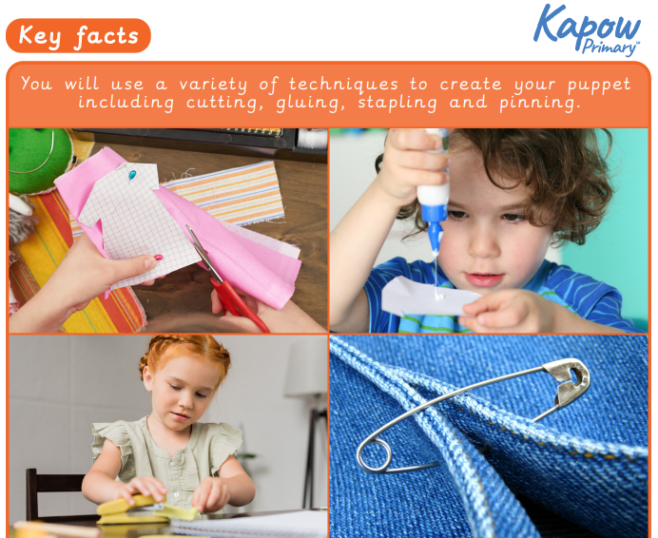  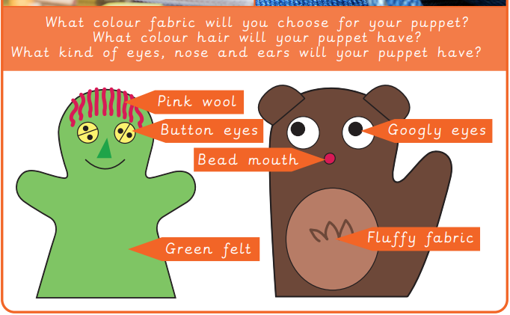 |  | Key Facts –  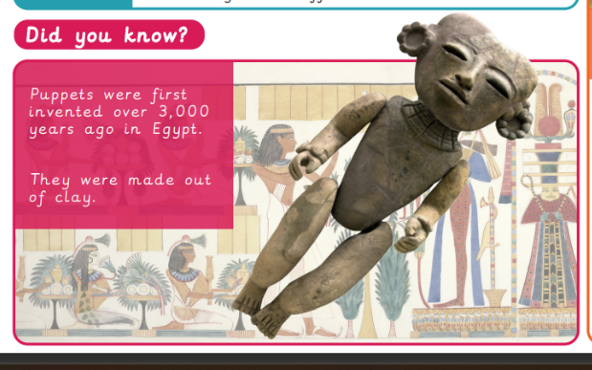  A puppet is an object, often resembling a human or anima, that is animated and manipulated by a puppeteer.  They were first made in Greece in the 5th Century.  They are often used to tell stories.  We are learning to:  - Join fabrics together using glue, staples and pins.  - Design a puppet and use a template.  - Join two puppets faces together as one.  - Decorate a puppet to match a design. | Key words:
  Decorate | To add details to a design to improve its appearance
  Design | To make, draw or write plans for something
  Fabric | A natural or man-made woven or knitted material that is made from plant fibres
  Template | A stencil which you can use to help you draw a shape more easily on to different materials
  Stencil | A shape that you can draw around
  Model | A practise version, often on a smaller scale, that lets you test out your idea and see how it will look and work
  Glue | A sticky liquid that can hold two things together
  Hand puppet | A toy that you can move by putting your hand inside it
  Safety pin | A “U” shaped pin with a cap where the needle slots in securely after fastening
  Staple | A piece of thin wire which binds two pieces of paper together

