
Welcome back Year One! Can you believe we only have 7 weeks left of the year? It’s flown by and I have loved teaching you all. This half term is filled with exciting things, sports week, sports day, a trip to Temple Newsam and we will be having our Phonics Screening check too. Let’s make this last half term the best!
Maths | English | History | DT
In Maths we will be looking at money. We will be learning to recognise coins and notes. We will be using our counting in 2’s, 10’s and 5’s skills to help us count an amount of coins.  We will also be learning to tell the time to the hour and the half hour.  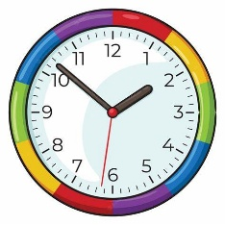 | In English we will be looking at the story “Elliot the midnight superhero” and we will be rewriting the story. We will also be writing a diary entry about our visit to Temple Newsam.  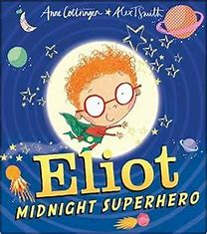 | We will be learning about Temple Newsam and the Victorians. We will be comparing how the Victorians lived and how we do. We will also be visiting Temple Newsam to help consolidate our learning.  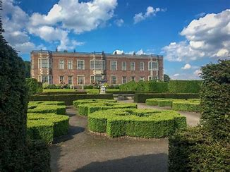 | In DT, we will be learning how to sew our own puppets. We will be learning how to join two pieces of materials together and we will design our own puppet.  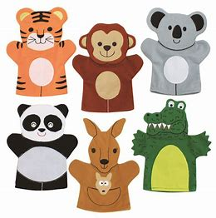

Important Information –  - Year One will have PE on a Wednesday and Thursday afternoon. Please ensure they have their PE kit with them on these days.  - The phonics screening check will be commencing the week beginning 8th June. Please ensure your child comes to school every day.  - Sports and well being week will commence on the week beginning 15th June.  - The Summer fair will take place on the 3rd July.  - The trip to Temple Newsam will be on the 16th June.  - We break up for the year on the 17th July. | Things to know –  - Each Friday, the children will complete a spelling test. Spellings will be sent home on a Friday and should be practised at home.  - Reading records and books should be brought in to school on a Thursday. Please ensure you are reading at home with them too.  - New library and reading books will be sent home on a Friday for the children to read over the weekend.

Keep up to date with your child’s learning by going on to the school website and see what they have been doing. Year 1 | Cross Gates Primary School .Any questions about your child or their learning, please feel free to come to me to arrange a time to meet.

