Camp Green Lake: where boys get a taste of their own medicine.
Introduction:
Work, learn, transform. Parents are u sick and tired of your disobedient, mischievous and impish devil-like? This is Camp Green Lake (which has no lake and no green), where it is harsh, it is humid and it is helpful. When these “fake” criminals arrive here, they will already regret … EVERYTHING. Since we only dig, only eat and Only sleep, they will eventually see how nicer it is at home, and will now appreciate all the luxuries you gave them; they will be begging to go home. They have NO choice, NO say and NO excuses, if this welcoming has intrigued you…read on!
What is Camp Green Lake?
Located in the most humid part of America, Texas, is Camp Green Lake- a juvenile detention camp where boys aged from moaning 13-year-olds to selfish 17-year-olds come for a transformation of a life time. The weather here is 35 degrees+! So, your boys might catch a tan digging in the Texas sun. Because it is EXTREMELY harsh here, we expect nothing but work and sleep.
What do the boys do/learn?
Here it’s the perfect place for your ill-behaved son to learn responsibility, respect and resilience; it’s so austere you can’t even imagine. Every morning, the juveniles wake up at 4:30 am (on the dot) if they don’t, they will be punished to digging 3 holes while the rest do 1. Their breakfast spoon will turn into a shovel in under ten minutes. So, parents, what do you say?
Reasons to send your son here:
Still need to be more convinced? Let this adventurous camp change that. If you feel like you’ve struggled your whole life with your son, he will soon get a taste of that because 99.9% of boys have transformed by our institution (owned by the Walker family). This place is a MUST there are: no screens, no excuses and no fun! Surely your convinced now!
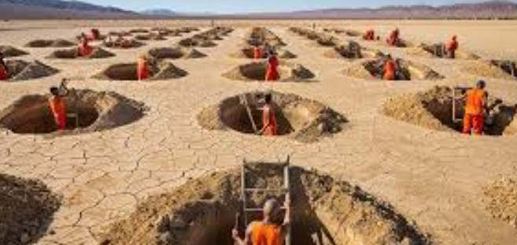
Here’s what some parents have to say:
“I will never ever! regret sending my boy to Camp Green Lake!”
“I am so grateful for you Camp Green Lake you’ve changed my life!”
“I am beyond proud; my son is always a delight to have now!”
Quote said by a boy who went to Camp Green Lake:
“This camp really changed me and my family’s life!”
Conclusion:
I hope this leaflet persuaded you to bring your sons here. If so message www.Campgreenlake.Com ,this is the perfect place (and you know it) so what are you waiting for, book your son a place 2026-2027 NOW!

