CAMP GREEN LAKE CHANGING LIVES
Introduction
Are you looking for a place to discipline your disobedient, unruly and wicked devil? Well, here is the solution of your dreams: Camp Green Lake. It is stern, it is humid, it is helpful. Before the juveniles arrive at the camp, they, were ill-behaved, wild and rebellious, but after they leave, they are considerate, thoughtful and well-mannered. This leaflet will be the answer to your prayers.

What is Camp Green Lake?
Camp Green Lake is a life changing juvenile detention centre, which is located in (the hottest part of America) Texas. 13–17-year-old boys attended the camp for a once in a life time transformation. Did you know it is over 35 degrees in the shade and in the scorching hot sun it is 60 degrees? Because it is over 100 miles away from any water supply, people don’t leave. It is forbidding, it is blistering, it is a prison.

What they do.
They dig, sleep, eat. These are 3 words that sum up what the children at Camp Green Lake do. By following our harsh forbidding rules, your devil will soon learn responsibility, respect and resilience. Waking up at 4:30am, boys do this to avoid the blazing hot sun which will burn their skin if not careful. Because it is so forbidding. The camp promises to change your disobedient boys.

WHY CHOOSE CAMP GREEN LAKE?
Still not convinced? Well, this will show you that Camp Green Lake is the one. Your boy will transform into a thoughtful, considerate, courteous, cultured.
Parents agree
“Thank you, Camp Green Lake, you have transformed my little boy!”
“I have nothing bad to say about Camp Green Lake!”
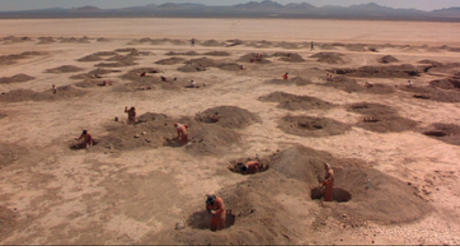
“I will NEVER regret sending my son to Camp Green Lake!”

This what former Camp Green Lake member said.
“Camp Green Lake has made me a better person!”

Conclusion.
Are you ready to send your boy to Camp Green Lake? How to send your boy to Camp Green Lake: visit our website (www.campgreenlake.com) no bad behaviour, no bad attitude, no bad regrets. Its only £100 pounds a month! So, book your tickets NOW, for a transformation of a lifetime!

