Happy New Year! I hope you have had a lovely break; I am very excited for this half term. I was so impressed with all of the children in Year One last half term in all areas of their learning, I can’t wait to become even prouder of them over the next couple of weeks.
Maths | English | Geography | Art
In Maths, we will be learning our numbers to 20. We will be finding out what numbers are hiding in our teen numbers and then we will be looking at addition and subtraction using numbers up to 20.  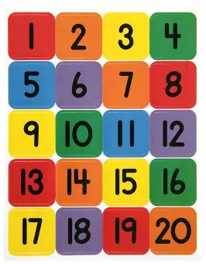 | In our writing lessons, we will be retelling the story of “Lost and found” by Oliver Jeffers. We will be focussing on using connectives in our work along with ensuring our handwriting is being formed correctly.  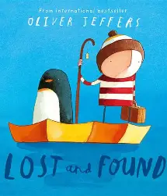 | In Geography, it is all about hot and cold countries! We will helping Paddington plan his holiday destination. We will learn about different weather patterns in the UK. We will also find out about the equator and where hot and cold countries are in relation to this.   | In Art, we will be looking at painting and mixed media. We will be learning about primary and secondary colours and we will be finding out how to use two colours to create a new colour.  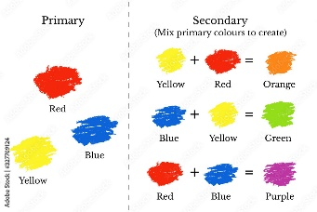

Important Information –  - Year One will have PE on a Wednesday and Thursday afternoon. Please ensure children come to school in their full PE kits on these days and any earrings they are wearing are taken out.  - Please regularly read with your child and write a comment in their book, informing us about how they have read and their successes.  - Please try and ensure your child comes to school on time and is present every day for them to achieve the most they can. | Things to know –  - Each Friday, the children will complete a spelling test. Spellings will be sent home on a Friday and should be practised at home throughout the week.  - Reading records and books should be brought back on a Thursday and will be kept overnight to be changed. Please read with your child during the week and write a comment in their records.  - Children will return home on a Friday with a library book that they have picked – this should be returned on the following Thursday with their book bag.
Any questions you may have, please feel free to come and arrange a time to speak with me. Keep up to date with your child’s learning by going on to the school website and see what they have been busy doing! Thank-you for all of your continued support and for all of the hard work that you do at home with your child. – Miss Robinson

