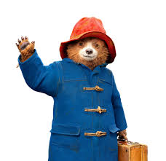 | Hot and Cold Locations |  |  | 
 | Year Group: 1 | Subject Focus: Geography | Term: Spring 1
Key facts  - Recap: United Kingdom is made up of four countries; Scotland, Northern Ireland, England and Wales. We live in England.  - The whole world is split into seven continents. England is in a continent called Europe.  - The continents have different climates because of where they are on the Earth.  - Places which are closer to the equator are the warmest.  - Places which are furthest from the equator are very cold.  - When we are finding directions, it is useful to know North, South, East and West. |  | 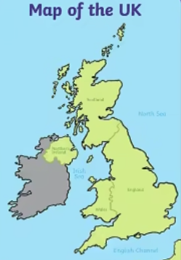  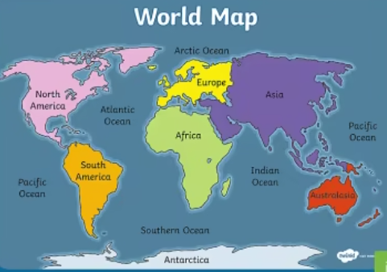  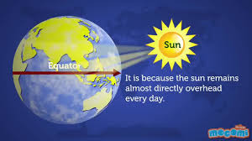 | Key words:
  Antarctica | the continent furthest to the South of planet Earth. It is almost entirely covered in ice.
  capital | the city where the government sits. London is the capital city of England and the UK.
  climate | a measure of the weather in a certain area over a long time.
  country | an area of land inside a country
  continent | a huge mass of land. There are seven continents in the world.
  equator | an imaginary line around the middle of the Earth, which separates the Northern and Southern hemispheres.
  Kenya | a country in East Africa. The equator crosses through Kenya.
  Southern hemisphere | the area of Earth that is to the south of the equator.
  Northern hemisphere | the area of Earth that is to the north of the equator.
  South Pole | the most southern point on Earth. It is found in Antarctica.
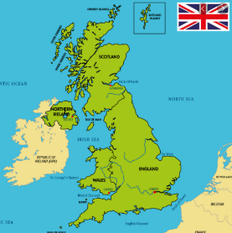
Key places:
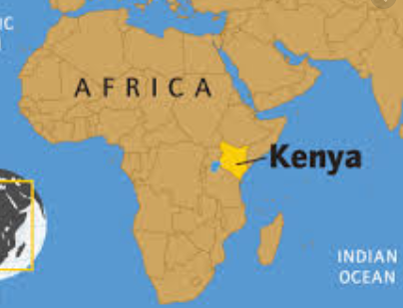
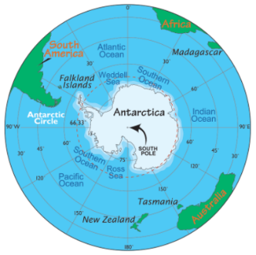
 |  | Exciting books/ web links:  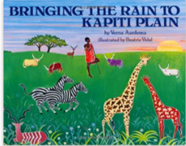    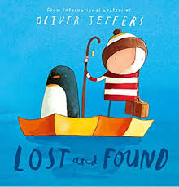  https://www.bbc.co.uk/bitesize/topics/zyhp34j/articles/zjg46v4  https://www.bbc.co.uk/iplayer/episode/m00086jq/go-jetters-series-3-7-go-jetter-heroes-polar-explorers  https://www.youtube.com/watch?app=desktop&v=4z5JEt-hnek  https://www.bbc.co.uk/iplayer/episode/b08g6r5p/go-jetters-series-1-46-maasai-mara-national-park-kenya | Parents as partners:  - Visit a local Travel Agents and look at the brochures. What would you take on a holiday to a hot place? What would you need to take if you visited a cold place?  - Look at a map or globe. Can you find the United Kingdom?  - Research the animals that live in the Antarctica and Africa. How do you think they can survive in very cold or very hot temperatures?

