 | Art: Painting
 | Year Group: 1 | Subject Focus: Art | Term: Spring 1
Skills  Painting skills  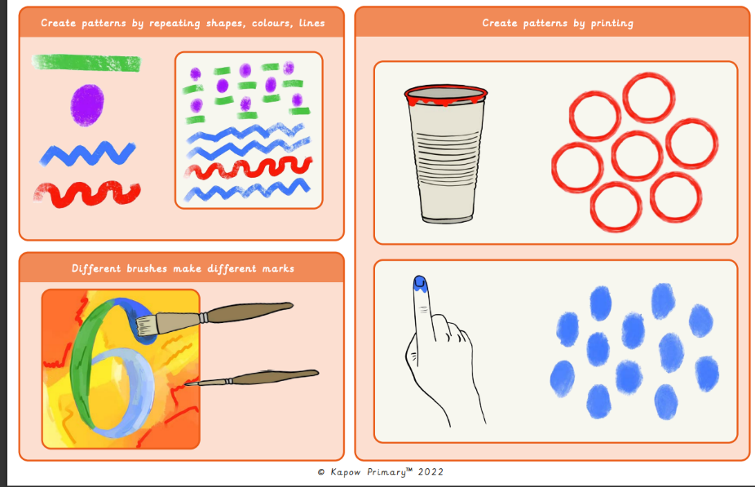  Primary and secondary colours  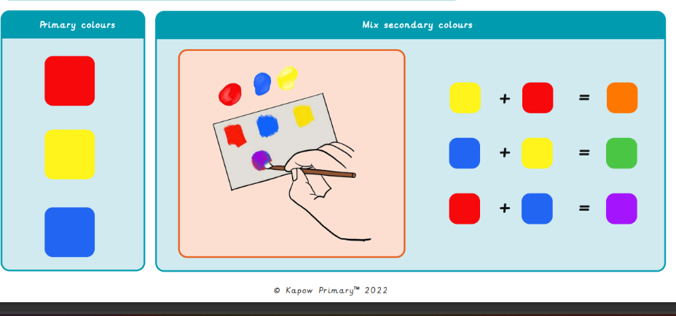 |  | Famous Artwork:  Clarice Cliff –  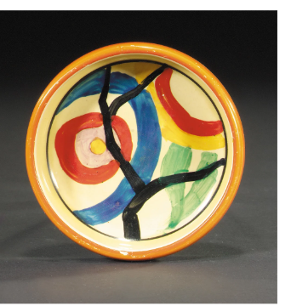  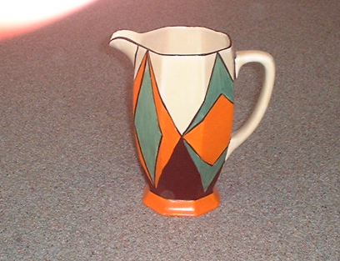  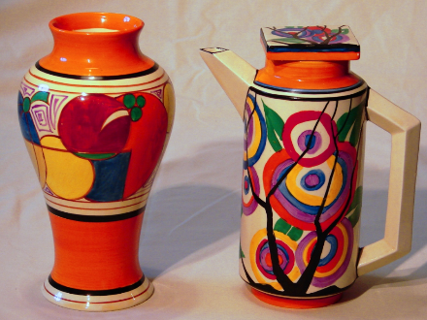 | Key words:  About the artists:  Clarice Cliffs  - She was an English ceramic artist and designer!  - She was the head of Newport Pottery factory creative department.  - She is best known for her amazing plates.  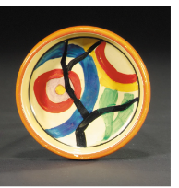
  Primary colours | Red, yellow and blue
  Secondary colours | Orange, green and purple are made by mixing other colours together
  Mix | Combining two or more colours together
  Pattern | Pattern is a design in which shapes, colours or styles are repeated
  Hue | Describing an exact colour, eg sky blue
  Print | Transferring an imagine onto another surface, eg finger painting
  Blend | When you mix two substances together
  Shade | Shade shows how light or dark something is
  Texture | The feel or appearance of a surface
  Shape | When lines join together to form a shape.

