Monster Mayhem Across Denmark!
During the darkest, gloomy hour of midnight, a blood-thirsty, brutal beast awakened, and tragedy struck the once welcoming hall of Heorot. The uncontrollable, vile monster- Grendel- charged into Heorot, exterminating 30 innocent, trembling lords and left Heorot a terrifying slaughter-house. This unstoppable, merciless creature, who despises the sound of laughter and the feeling of joy, knew he had to stop this tragic mess.

The Daily Dane Mail

After two years of never- ending effort, Heorot was finally built – and what a stunning mead-hall it was, deep brown wooded walls, warm cozy fires and luxury benches that went on forever.
To celebrate this welcoming mead-hall they had a huge feast; it was the best King Hrothgar ever had, and everyone was there. Once it had finished the queen laid out the beds and everyone went to sleep.
As the drowsy Danes said their goodnights, nobody expected that a bloodcurdling creature was stalking in the mist as they spoke, listening to their every word! At around 11:59, the monster stormed through the once sturdy door of Heorot (with immense power) unleashing chaos within.
Seconds later, this nauseating, enraged beast snatched the first helpless man with his bloodstained claws, devouring his insides, crushing bones and skulls, sipping blood and snapping veins! Ear-splitting screams flooded the once merry hall as the beast gobbled person, after, person, after person, leaving nothing but blood and demolished benches. Eyewitnesses described the attack as petrifying, dramatic and gruesome (no one had time to flee).

Journalists have interviewed terrified survivors and their trembling families to capture their thoughts and feelings about the vicious, traumatic attack on their beloved Heorot.
“It’s terrible, simply horrible,” cried the nervous villager, who felt like leaving the town!
“How could this be happening? I cared for this town so very much,” sobbed King Hrothgar (sitting on the ground in great sorrow).
“I shall destroy this cruel, evil beast even if I die, but I have to try! announced Beowulf (boldly).

King Hrothgar is swimming in sorrow feeling defeated and distraught; he believes no one could ever stop this terrible fate.
Thankfully, a rumour has circled the town of Denmark and an unbeatable hero is on the way- handsome prince Beowulf.
With many citizens already lost to the beast, everyone knows one thing for certain; this beast must be eliminated, once and for all.

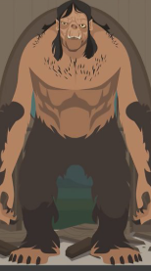
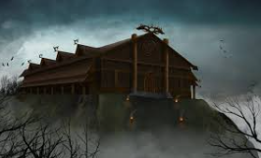

Grendel, the devious monster who destroyed King Hrothgar’s heart.
Heorot, the now unwelcoming mead-hall.

