 | Electricity
 | Year Group: 6 | Subject Focus: Science | Term: Autumn 1
Key facts  - Electricity was not invented - it was discovered by humans. The energy was always there on Earth but needed someone to find that spark.  - The brightness of a bulb is affected by the voltage in the circuit - the lower the voltage, the dimmer the bulb.  - Changes to components in a circuit has an effect on the brightness of its bulb or the volume of its buzzer.  - Electricity comes from the power station, the wind, the sun, water and even an animal’s poo!  - Electricity is a type of energy that builds up in one place (static), or flows from one place to another (current electricity). |  | Components of a circuit and their symbols.  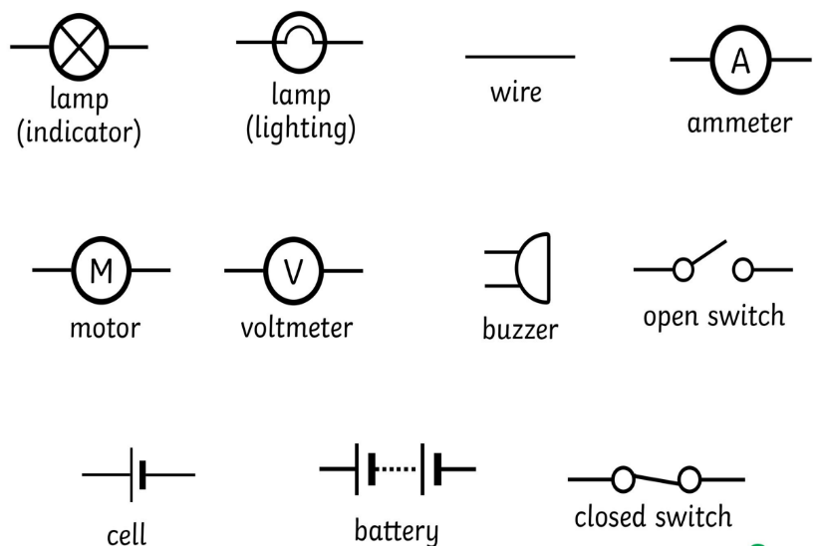 | Key words:  battery A device that stores chemical energy until it is needed. A battery is a collection of cells.  Bulb / lamp Converts electricity to light or heat.  buzzer A component that can create an audible tone or make a sound.  cell A device that stores chemical energy until it is needed. A cell is a single unit.  circuit A path that an electrical current can flow around.  component A part or device within a circuit.  motor Converts electricity to movement.  resistance The difficulty that the electric current has when flowing around a circuit.  switch Opens and closes the circuit.  voltage The force that makes the electric current move through the wires. The greater the voltage, the more current will flow.
Did you know?
- Lightning is caused by the discharge of electricity in the atmosphere.
- Electricity travels at the speed of light. That's more than 186,000 miles per second!
- Alessandro Volta – Italian physicist who is credited with inventing the battery
- Edith Clarke – American scientist who was the first woman to be professionally employed as an electrical engineer in the United States
- Benjamin Franklin - most credited for discovering electricity in 1752. In an experiment, he attached a wire to a kite in a thunderstorm, which showed that lightning consists of electricity.

 |  | Exciting books / web links:  https://www.makerspaces.com/squishy-circuits/  https://www.bbc.co.uk/bitesize/topics/zj44jxs  https://www.stem.org.uk/resources/community/collection/12390/year-6-electricity  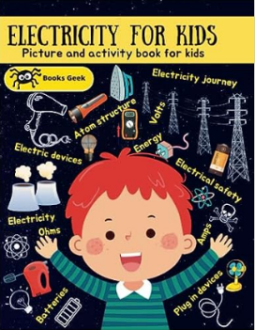  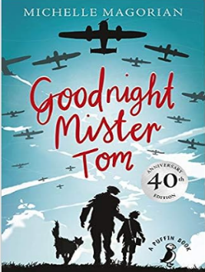 | Parents as partners:  - Investigate how much the electricity for school or home costs and how we could save money.  - Write a persuasive letter to parents or others in the community encouraging them to use less electricity.  - Discover how life different in times before electricity? What electrical devices do we have now that weren’t around in the past?  - Create electrical games such as an ‘Operation’ style game or a steady hand game where a hoop must be moved without touching a metal wire.  - Encourage your child to research how electricity is used in the modern world  - Create a fact file about Alessandro Volta, Edith Clarke or Benjamin Franklin.

