Year 6 Newsletter (Spring 1)

Welcome back to Blackman Class in year 6! As we continue on our journey through year 6, we look forward to lots of learning and exciting projects this half term.
Our learning journey
This half term we will be focusing on geography. We will investigate why the rainforests are so important by looking at the human and physical impact of rainforests on our planet. We will also be linking our art lessons to this topic. There are some interesting facts about this topic on our knowledge organiser.  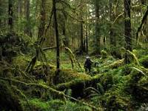 | Science will see us continuing our work on the heart and circulatory system. We will then investigate living things and their habitats. We will learn all about how to use and create classification keys. During these lessons, we will think about how the different plants and animals can be categorised.  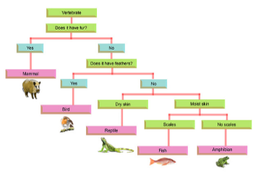 | In our Maths lessons we will focus on ratio, algebra and decimals. We will also be doing extra maths work in order to speed up our arithmetic skills. It is vital that the children continue to work on times tables and mental maths at home as well as in school.  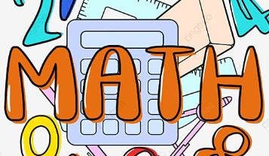 | In English we will write adventure stories linked to rainforests. We will also create balanced arguments about deforestation.  In our reading lessons we will be using the text ‘The Great Kapok Tree’ and several non-fiction texts linked to our topic: rainforests.  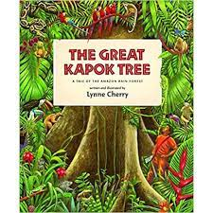

Diary Dates:  Reminder that our residential to Liverpool will take place on Mon 24th June – Wed 26th June. More details and payment information will be shared this term.  PE will continue to be on a Monday and Thursday. The children need to come to school in their uniform and change into their PE kits just before the lesson. | Class routines:  - The children are expected to read at home every night and have their reading record signed by an adult. This is the single most useful thing that parents can do to support their children’s learning.  - Each Friday, the children will complete a spelling and mental maths quiz. The spellings and maths focus will be sent home on a Friday, ready to learn for the following Friday. The children will need to work on these at home (and at school) on a regular basis. Please access PurpleMash to help with this.  - Pupils should continue to log onto TTRockstars to improve their times tables knowledge.

Finally, please remember to log onto the class page on the school website to keep up to date with our latest news: https://www.crossgatesprimary.co.uk/class-pages/ or by accessing the school twitter page.
Miss Wilson & Miss Cantwell

