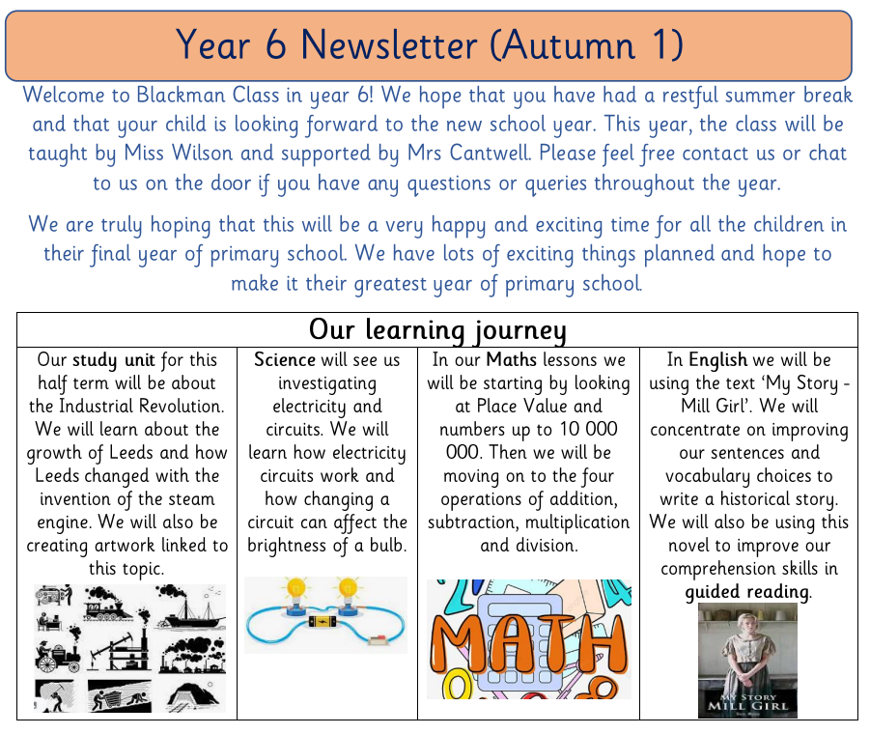

|  |  |
| --- | --- |
| Diary Dates:  PE will take place on a Monday and Thursday. The children need to come to school in their uniform and bring a full PE kit on these days. They will also need a water bottle.  Bikeability will take place from Mon 25th Sept – Fri 29th Sept. More details will be shared about this soon.  Please apply for high school places before the deadline of Oct 31st. See the class website page for an online link.  Our residential to Liverpool will take place on Mon 24th June – Wed 26th June. More details and payment plans will be shared this half term. | Class routines:   * The children are expected to read at home every night and have their reading record signed by an adult. This is the single most useful thing that parents can do to support their children’s learning. * Each Friday, the children will complete a spelling and mental maths test. The spellings and maths focus will be sent home on a Friday, ready to learn for the following Friday. The children will need to practice these at home (and at school) on a regular basis and their scores will be shared. * Pupils should continue to log onto TTRockstars to improve their times tables knowledge. * All pupils have access to Purple Mash. They should log on and complete the ‘To do’ activities. |

Finally, please remember to log onto the class page on the school website to keep up to date with our latest news: <https://www.crossgatesprimary.co.uk/class-pages/> or by accessing the school twitter page.

Miss Wilson & Miss Cantwell