Year 6 Newsletter (Autumn 2)

Welcome back to Blackman Class in year 6! As we continue on our journey through year 6, we look forward to lots of learning and exciting projects this half term.
Our learning journey
Our Geography unit for this half term will be linked to the water cycle and rivers.  We will learn about the rivers of the world and look closely at the features of a river during these lessons.  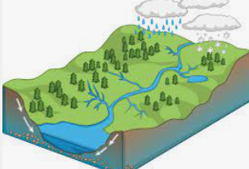 | Science will see us investigating the heart and circulatory system. We will learn all about how the heart works and how blood is transported throughout our bodies.  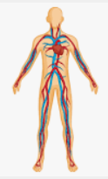 | In our Maths lessons we will continue our work on multiplication and division methods and will then be moving onto fractions. In order to be successful in these lessons, it is essential that the children continue to work on their times tables and speed up their recall of times table and division facts.  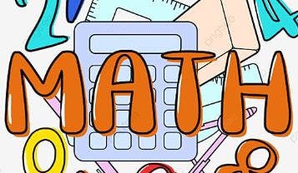 | In English we will be using the text ‘Oliver Twist’. We will concentrate on empathising with characters and creating diary entries. We will also be using this novel to improve our comprehension skills in reading lessons.  We will also be writing reports linked to our topic of rivers.  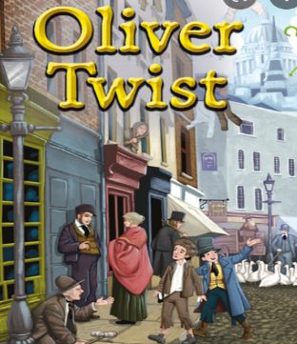

Diary Dates:  PE will take place on a Monday and Thursday. The children need to come to school in their uniform and bring a full PE kit on these days. They will also need a water bottle.  The whole school will be going on a visit to the theatre on Tuesday 5th Dec. We will be watching Oliver Twist which links to our English and Reading focus this half term.  Our residential to Liverpool will take place on Mon 24th June – Wed 26th June. More details and payment plans will be shared soon. | Class routines:  - The children are expected to read at home every night and have their reading record signed by an adult. This is the single most useful thing that parents can do to support their children’s learning.  - Each Friday, the children will complete a spelling and mental maths quiz. The spellings and maths focus will be sent home on a Friday, ready to learn for the following Friday. The children will need to practice these at home (and at school) on a regular basis.  - Pupils should continue to log onto TTRockstars to improve their times tables knowledge. They also have access to Purple Mash where optional homework will be set on a weekly basis.
Finally, please remember to log onto the class page on the school website to keep up to date with our latest news: https://www.crossgatesprimary.co.uk/class-pages/ or by accessing the school twitter page.
Miss Wilson & Miss Cantwell

